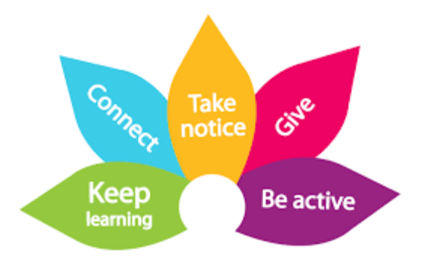

Be Active

We have included ideas which link to the pillars of wellbeing from the Somerset Wellbeing Framework

Sleep – Diet – Activity

Information about the Somerset Wellbeing Framework can be found on our website: www.cypsomersethealth.org/new_home

Be active…

Making sure you do physical activity is proven to make people feel better both now and in the future. It’s good for you physically and emotionally.
Being active doesn't just mean doing sports and exercise. It doesn’t need to be particularly intense for you to feel good but the more it is, the better you’re likely to feel.

Today, why not get physical? Here are a few ideas:

• Go for a walk at lunchtime
• Help carry the shopping
• Do some ‘easy exercise’, like stretching, in the morning to start your day

What do you currently do to Be Active? …………………………………………………………………………………………………

What could you do to Be Active more? …………………………………………………………………………………………………

Sleep
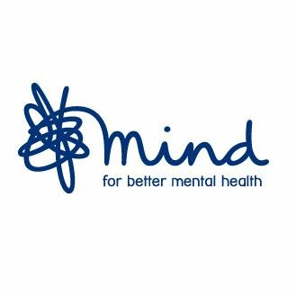
Being active is one of the supporting your wellbeing options for children and young people on the mind website. Regular exercise can improve our mood and self-confidence, increase our energy and help us sleep better. Take a look Here for things you could try.

This Sleep LibraryCast discusses the importance of exercise and routine in ensuring improved sleep. You can watch here on the link below:

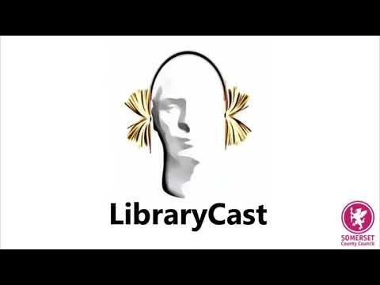
This video offers ideas for using mindful movement with young children. Using mindful movement during the day can help promote a sense of calm to later aid sleep. You can watch here on the link below:
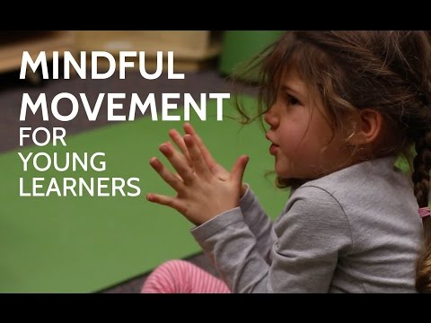
Diet

Healthy Eating and Healthy Weight
Developing good eating habits as a child has been shown to have significant impact on adult behaviours later in life and healthy eating; more than physical activity, has the greatest impact on achieving and maintaining a healthy weight for both adults and children.www.cypsomersethealth.org/?ks=1&page=f2f_food_h_eating

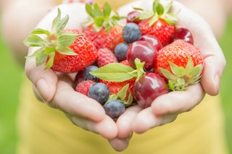
These 8 practical tips cover the basics of healthy eating and can help you make healthier choices.
www.nhs.uk/live-well/eat-well/eight-tips-for-healthy-eating/


Get Active in the kitchen - making positive changes to our diet can help us feel better and motivated to engage in physical activity. You could share your kitchen creations with a friend or family member.
Try out these recipe cards from Zing -


Activity
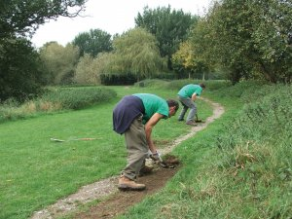
Gardening - While it may not be thought of as a traditional way of keeping active, getting out in your own back garden and doing some work can be an easy and simple way to get some fresh air and get moving. Doing something out in your own garden is also a great way of supporting your emotional health and wellbeing.

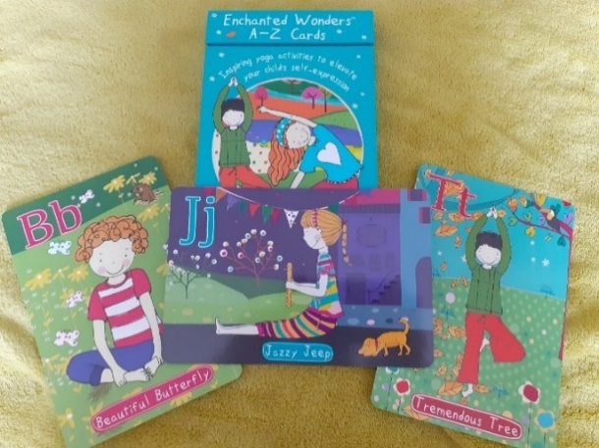
Challenge - These Enchanted Wonder Mindful Movement cards offer a great way to introduce yoga to children.
See if you could make your own name set by creating alphabet names to a movement for each letter of your name.

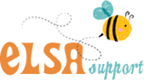
The Elsa Wellbeing calendar for June has some great tips to support children and young people’s wellbeing.
Why not have a go at active ideas such as: Day 3 - Take a photo at the same place each day for a week on a daily walk.
You can download this resource from the ELSA support website Here


The Brewhouse is now offering many of their usual live classes online. Available for all age groups, these include painting, ballet, arts and crafts and theatre skills. www.thebrewhouse.net/listings/activities/, including this tiny tots on line dance class: www.thebrewhouse.net/event/tiny-dancers-online/

For more information, advice and ideas for - How much physical activity children and young people aged 5 to 18 should do to keep healthy? See the NHS Live Well site Here

