The child first toolkit for reducing conflict between separated parents for practitioners July26
This workbook aims to put the wellbeing of children at the centre of any conversation with separated parents when ongoing conflict is involved. It aims to reduce time wasting conversations with separated parents + focus on helping them reduce conflict and move forward.

Suggested steps for managing the conversation:
- Allow the parent a maximum of 10/15 minutes to summarise the current issue is – the following questions may help focus the conversation on the impact on the children.
- Can you briefly summarise what happened?
- What led up to this? Were there any triggers or stressors beforehand?
- How did each of you respond?
- Was anyone else present, such as your child or other family members?
- Have you had a chance to talk about it since then? If so, how did that go?
- Was your child aware of or affected by what happened?
- Did it impact them emotionally or affect their behaviour?
- Have you spoken to your child about what happened?
- Either use the following questions listed below or the table to help the parent(s) reflect on the situation – putting their children at the centre.

  - Reflection questions for parent:

  - What happened? (The event)
  - What did you do? (The response)
  - What was the result, including what was the impact on your children? (The outcome)
  - What result would you have liked?
  - Were there other responses to the event you could have chosen?
  - What results might these alternative responses have led to?
  - How might you respond to similar events in the future to achieve better outcomes?

  - Use the table below to structure a conversation with the parent:
Situation | Thoughts | Emotions | Behaviour | Alternative thought

Information sheet: The impact of parental conflict on children
Top tip: Excellent video highlighting the impact of separation to show parents:
https://youtu.be/PMHeQO-rEfU?si=Md7w1dUXRegu6WXR
Below I have summarised some of the statistics – sometimes parents need to understand the impact their conflict is having on their children.
Please note there is a good news story here, the evidence is they can mitigate the impact of separation by investing in Positive Childhood Experiences – see below.

Mental and Emotional Health
- Increased Risk of Mental Health Issues: Children exposed to frequent, intense, and poorly resolved conflict are at higher risk of developing mental health problems such as anxiety and depression [1].
- Lower Self-Esteem: Persistent parental conflict can negatively affect a child's self-esteem and overall emotional well-being [2].

Behavioural and Social Development
- Behavioural Problems: Children may exhibit behavioural issues, including aggression and withdrawal, as a response to parental conflict [1].
- Social Difficulties: Conflict can impact children's ability to form healthy relationships with peers and adults [2].

Academic Performance
- Reduced Academic Attainment: The stress and instability caused by parental conflict can lead to lower academic performance and reduced school engagement [1].

Long-Term Outcomes
- Future Relationships: Children who witness ongoing conflict may struggle with their own relationships in adulthood [1].
- Employability: There is evidence suggesting that children from high-conflict homes may face challenges in their future employment prospects [1].

Physical Health
- Health Problems: The stress associated with parental conflict can also manifest in physical health issues, including increased risk of substance misuse [1].

Parental Influence
- Parenting Quality: Long-term conflict can affect how parents interact with their children, potentially leading to less quality time and increased hostility [2].
References [1] Reducing Parental Conflict: the impact on children - GOV.UK [2] Parental conflict - Barnardo's Family Space

The recovery time for children after a divorce or separation in the UK can vary significantly based on several factors. Here are some key findings from the evidence:

Initial Adjustment Period
- First Year: Many children experience emotional and behavioural changes within the first year following their parents' separation. This period is often marked by feelings of sadness, anger, and confusion [1].

Short to Medium Term
- 2 to 3 Years: Most children begin to show signs of adjustment and improvement within 2 to 3 years after the separation. However, they may still experience feelings of loss, especially during significant events like holidays and birthdays [1].

Long-Term Impact
- Ongoing Challenges: While many children adapt well over time, about 25% may face long-term mental health issues, including depression and anxiety [2]. The quality of co-parenting and the level of conflict between parents are significant factors influencing these outcomes [1].

Factors influencing recovery
- Parental Conflict: High levels of ongoing conflict between parents can prolong the adjustment period and exacerbate emotional and behavioural problems [1].
- Support Systems: Access to supportive relationships with family members, friends, and professionals can significantly aid in a child's recovery [2].

Overall, while many children adjust within a few years, the presence of supportive environments and effective co-parenting strategies are crucial for their long-term well-being.
References [1] Child outcomes after parental separation: variations by ... - GOV.UK [2] Inquiry: Better Outcomes for the Children of Separating Parents.

However, Positive Childhood Experiences (PCEs) can significantly reduce the negative impact of separation on children. Here is a short summary of how they help:

1. Maintain a loving relationship
- Show affection regularly—hugs, kind words, and quality time.
- Reassure children that they are loved and not to blame for the separation.

2. Have open communication
- Encourage children to express their feelings without judgment.
- Listen actively and validate their emotions, even if they’re difficult.

3. Create routines and stability
- Keep consistent daily routines (meals, bedtime, school).
- Ensure both parents are involved in the child’s life, if safe and possible.

4. Encourage positive relationships
- Support strong bonds with extended family, teachers, and friends.
- Involve children in community activities or clubs to build social support.

5. Model healthy coping
- Show how to handle stress and conflict in constructive ways.
- Avoid arguing or speaking negatively about the other parent in front of the child.

6. Celebrate strengths and achievements
- Praise efforts and accomplishments, no matter how small.
- Help children set and achieve personal goals to build confidence.

7. Seek support when needed
- Consider counselling or support groups for children and parents.
- Use school or community resources to provide additional emotional support.
Adults with 6–7 positive childhood experiences (PCEs) were 72% less likely to report depression or poor mental health compared to those with 0–2 PCEs For more information about Positive Childhood Experiences: https://positiveexperience.org/
What is coparenting?
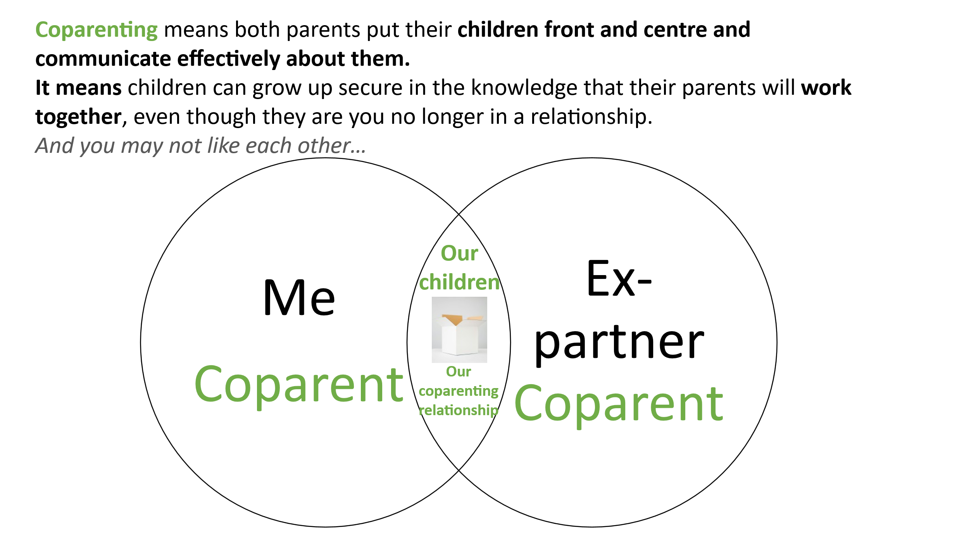
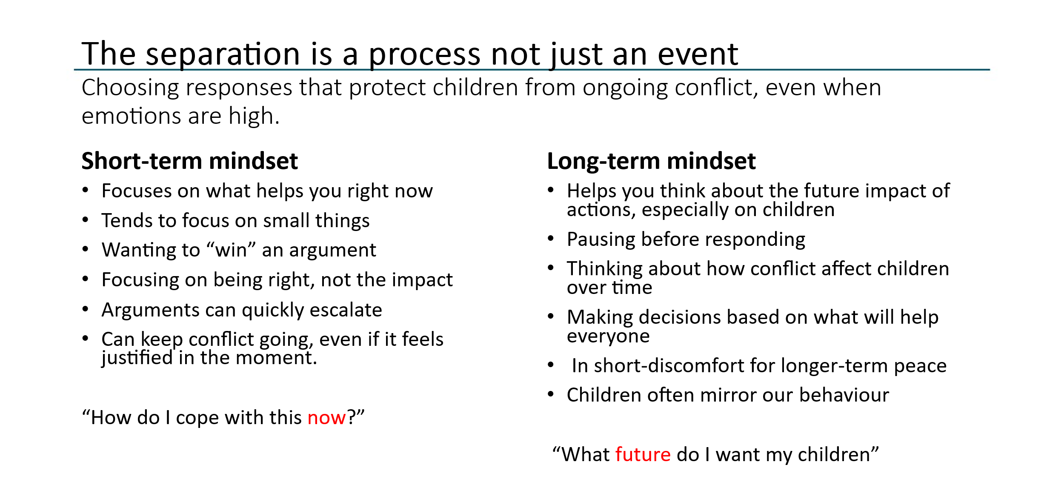
Having a long-term mindset
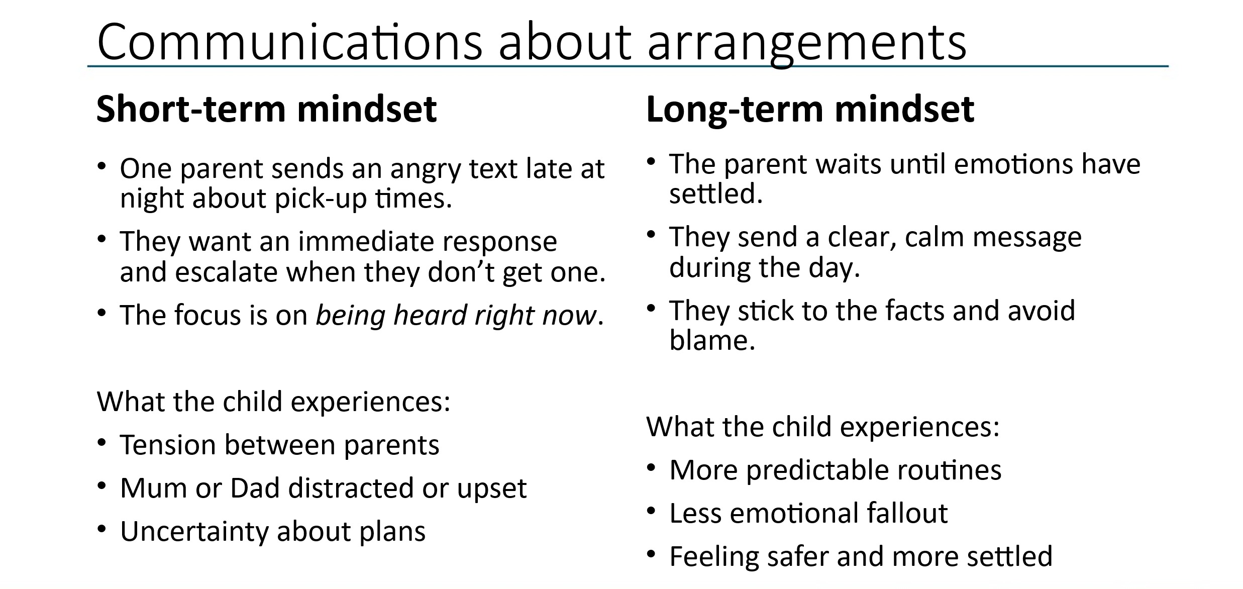
Exercise to do with parents:
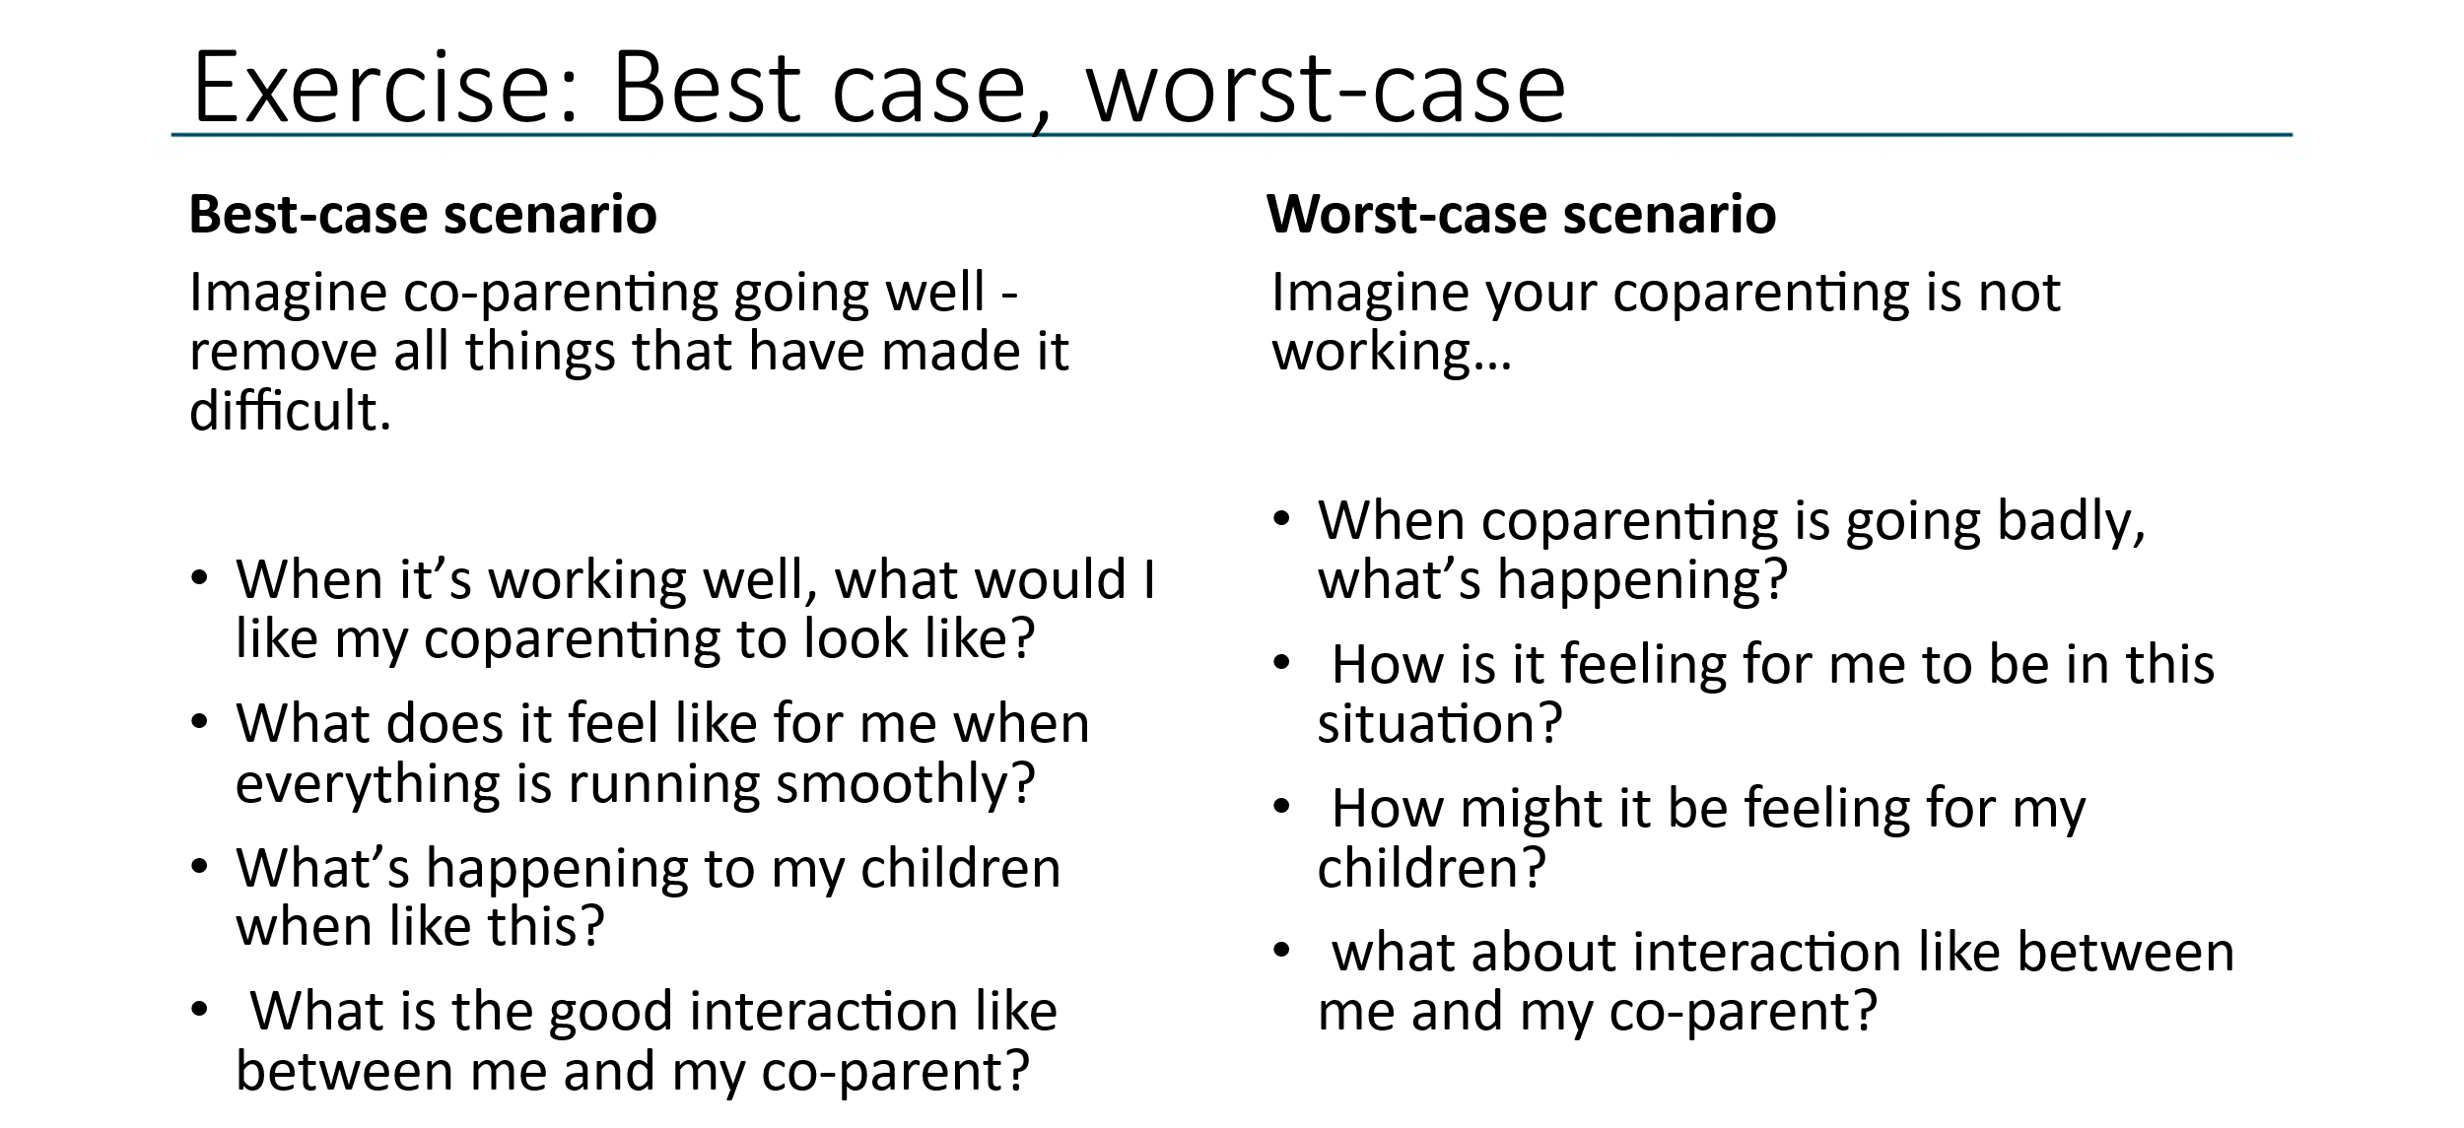
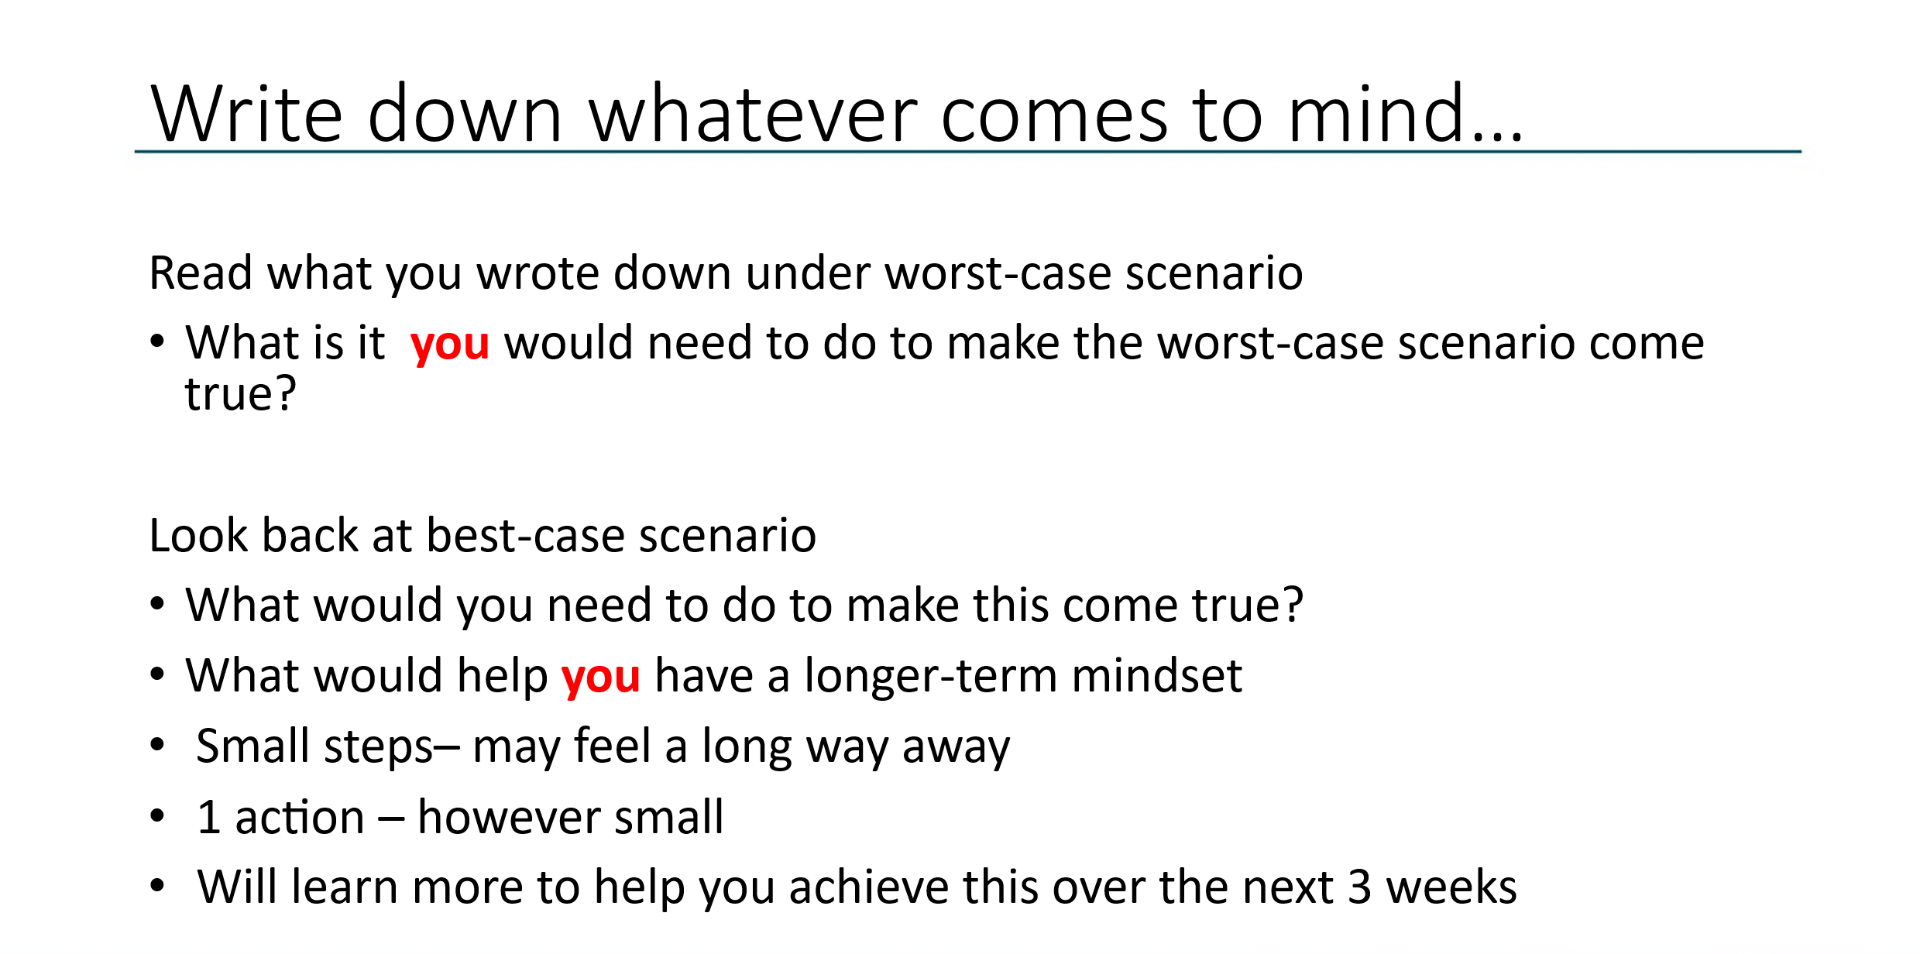

Exercise: The importance of perspective
To be a co-parent we need to acknowledge that our ex-partner has a perspective.
Key points
- Separation from your partner can sometimes be caused by a key difference of opinion, and those differences can be made worse when our emotions are strong. We may not trust them anymore. We may think they are incapable or useless.
- All this pushes our perspective further away from our co-parent’s, which can impact how you work together as you parent your children.
- Perspective helps you see the whole story when it comes to parenting your children – you are both their parents.
- Perspective can also help to reduce conflict between you and may help you to manage your emotions.
- Unfortunately, when emotions are high, we can become entrenched in our own perspective and unable or unwilling to take on board another viewpoint because we are trying to win and prove we are right – reinforcing the short-term mindset.
- This is about taking time to reflect on your situation and ask yourself, “How right are you?”
- Giving your ex-partner of voice maybe the last thing you want to do because it may feel like you are letting them win. BUT we are not – listening, hearing and seeing things from their perspective gives information and knowledge which will help us manage the situation.
- To be a parent, we must consciously and deliberately acknowledge that our ex-partner has a perspective as they are our children’s other parent.
Exercise: Standing in your co-parent’s shoes
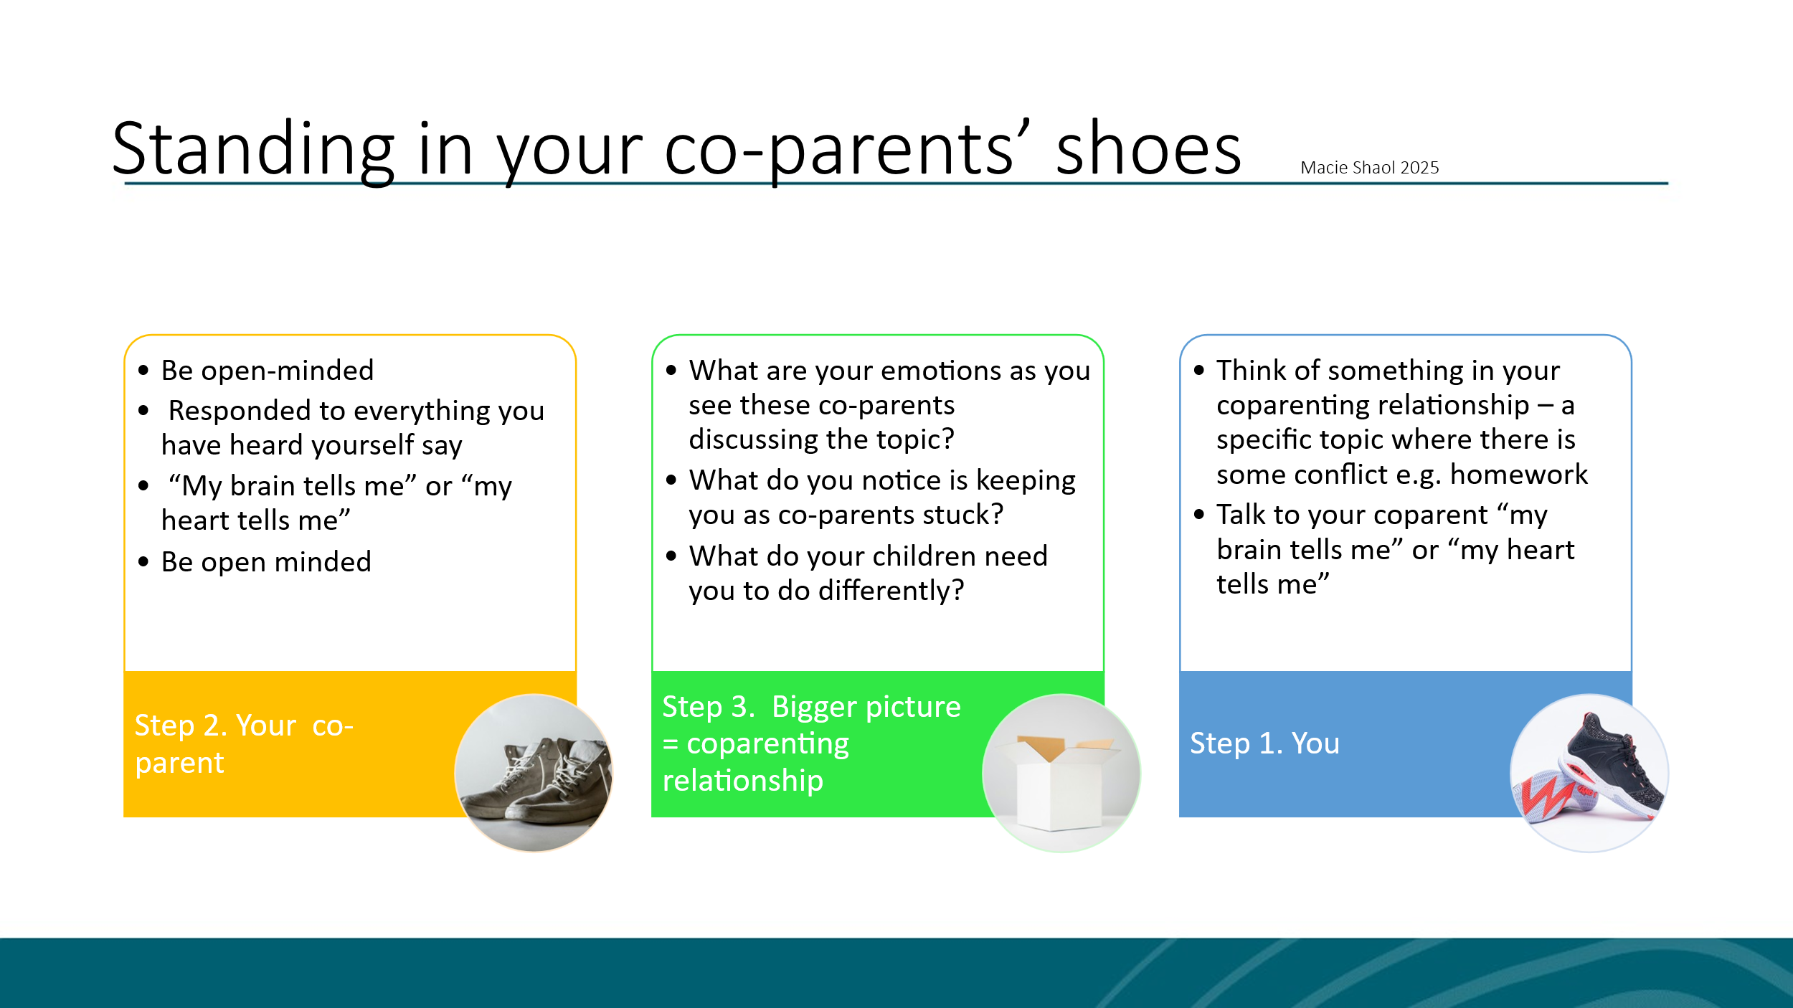

The exercise:
- Think of something in your co-parenting relationship that you and your co-parent are stuck on at the moment, a topic where there is some but not too much conflict. E.g. handovers, decisions about schooling, doing homework etc.
- Spend a moment thinking of the issue you want to resolve and perhaps write it down:

- Imagine 3 coloured circles on the floor: yellow, blue, green or use 3 chairs: yellow, blue, green.

- You = blue and imagine your co-parent standing opposite you.

- As YOU in the blue circle: Look at them and try to imagine they are there – now talk out loud about the topic you have written down using the phrases “my brain tells me” or “my heart tells me”.
This helps you see the situation from both an emotional and practical viewpoint. Tell your co-parents everything that you know about this topic. Do it respectfully and out loud.

NOTES:

- When you are finished, physically move to stand/sit in the yellow circle – be open-minded! You are now trying to see things from your co-parent’s perspective. YOU are now the CO-PARENT and now respond from your co-parents perspective to everything you have just heard yourself say. Use “My brain tells me” or “my heart tells me” phrases again.

NOTE: This may be hard but keep going, be open to new information. Remember, they are not really there… and you will know when it is time to finish.

- Keep moving back-and-forth between the blue and yellow until the topic is finished.

- Finally, stand or sit in the green area – this is the “bigger picture” or “the co-parent relationship” – this “bigger picture” knows everything about the relationship between you and your co-parent and deeply cares about you both. It cares that the coparent relationship works for both of you as well as your children. It might help if you imagine yourself rising up and looking down on both co-parents and using this to see the situation.

- Then, as the neutral co-parenting relationship, try to answer the following questions:
  - What are your emotions as you see these co-parents discussing the topic?

  - What do you notice is keeping you as co-parents stuck?

  - What do your children need you to do differently?

- Finally, answer the following questions:
  - Does anything feel different after this exercise?

  - What might your children need you to do differently in this situation?

  - What one practical action can you take, and when will you do it?

Information sheet: Managing emotions
Separation is an emotional rollercoaster as you and your children navigate feelings of grief and loss of what was, anger, depression and relief as you start to move on and create a new life for yourself and your children.
However, learning to manage our emotions as parents helps us to create a stable and supportive environment for our children, helping them cope with the changes and hopefully reducing coparenting conflict.
Learning how you can increase time in your green zone is key to helping you reduce conflict with your ex-partner.
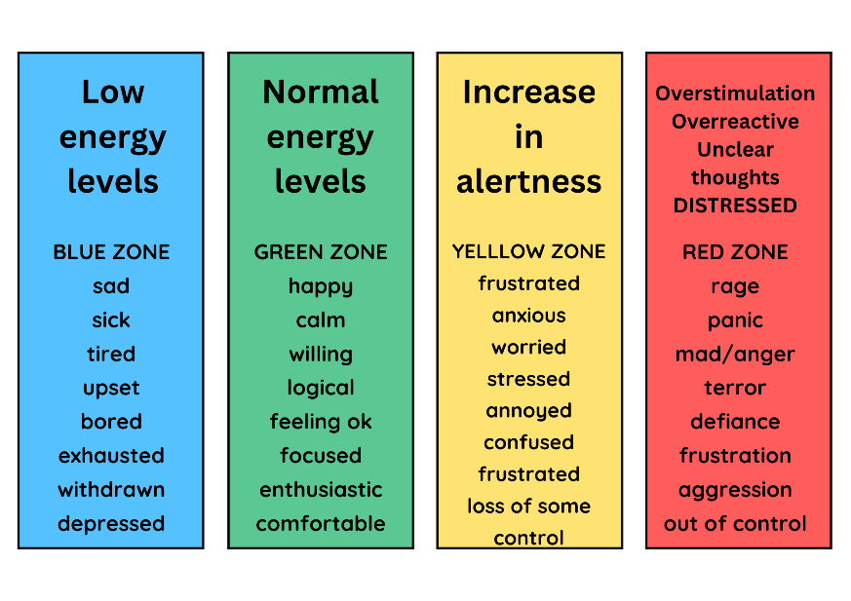

- What one positive change would help you get back and stay in the ‘Green zone’ emotionally for longer?
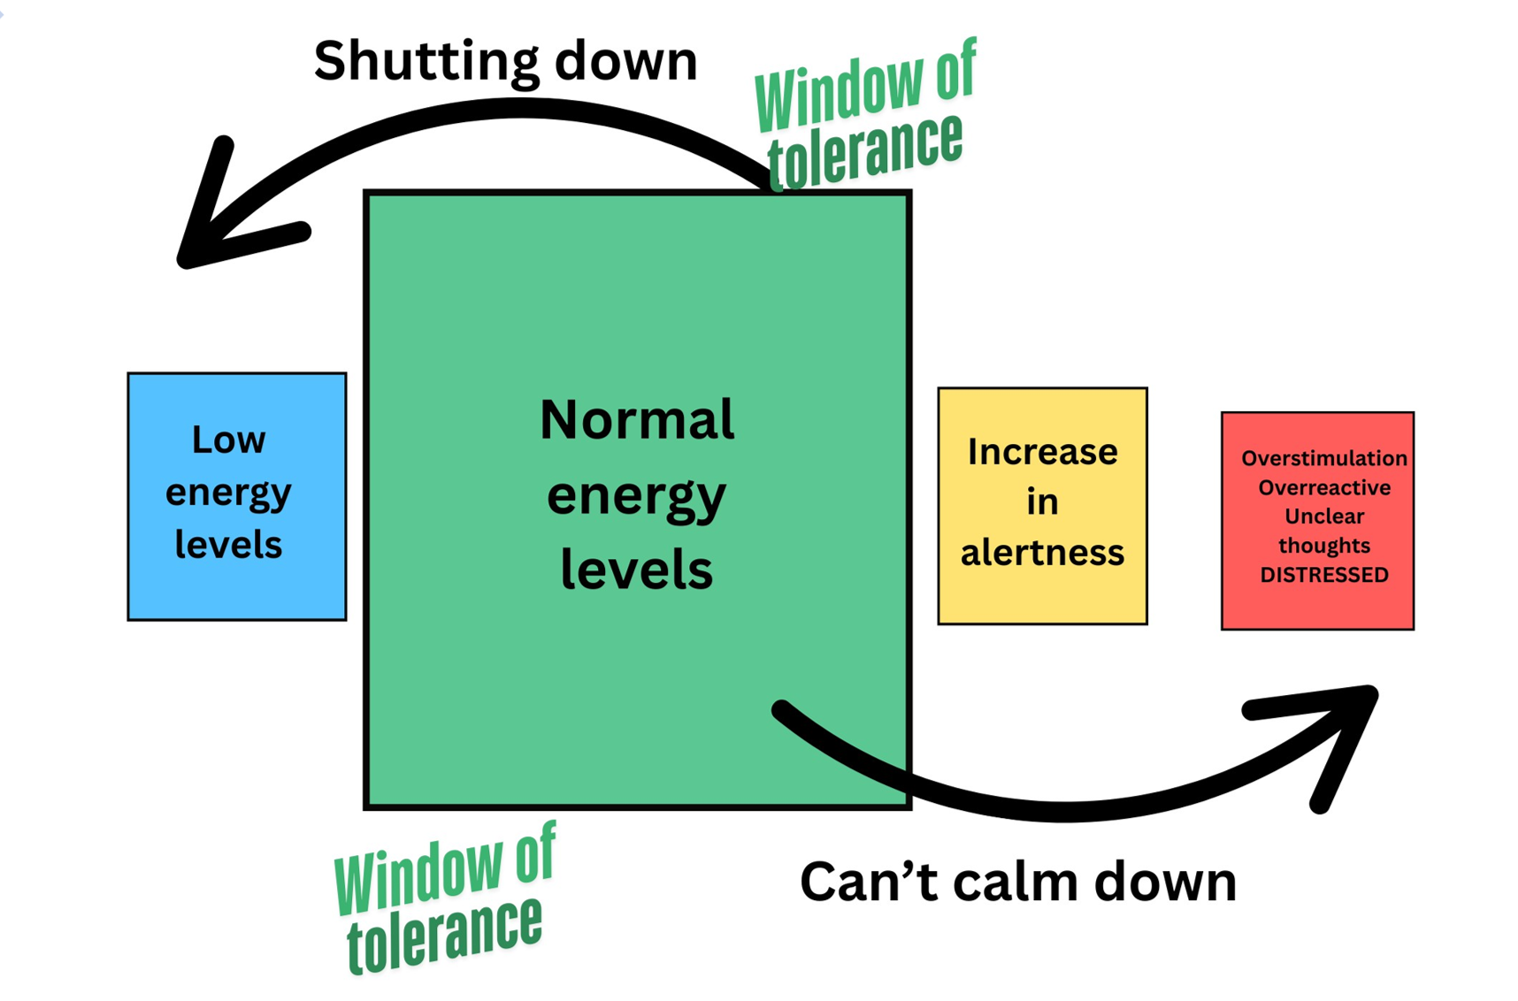

- What could you do to look after yourself in the short, medium and long term? And when are you going to do it?

Information sheet: Coping as a parent post-separation
The effect of separation on parents
- Depression: feeling sad and upset that the relationship is ended
- Guilt: many parents feel guilty about the decision to separate and worry about the impact on the children
- Anger: it is normal to feel angry response to the separation – at times it can be intense and difficult to manage
- Relief: in addition to the negative emotions, there may be feelings of relief and hope – especially if the relationship has been conflict and unhappy. It may be an opportunity to put difficulties behind you and start again.
Learning to cope
Your ability to cope is crucial to your child’s well-being. There are lots of simple things you can do to improve how you personally cope, including:
- Give yourself permission to put yourself first – taking time for yourself is not selfish.
- Be kind to yourself – sometimes we are much harder on ourselves narrowing thoughts than we would be to anyone else we speak to.
- Practice self-care and relaxation: parents under stress often stop eating well, exercising, or doing things they enjoy. This can cause even greater stress. This is the time that you really need to look after yourself e.g.
  - The well, exercise and get a good night sleep
  - Have times of relaxation
  - Do things you enjoy – the more refreshed you are, the more available you are to help your children.
- Give yourself time
  - Remember that coping with separation is a long process and it can be cyclical
  - There will be bad times when you feel low or upset, but remember that these will pass and things will get easier as time goes by
- Get the right kind of support
  - Don’t go through this alone
  - Find friends and family members who you feel can support you – don’t forget that they may be also going through upset when a relationship breaks down so may bias
  - Try and find people who have some distance from the situation and who can give you a more balanced view
  - At this point, you may find counselling helpful
- Begin the healing process
  - Frequently, the hardest thing to do is forgive yourself or your former partner and move on
  - Make a decision to start the healing process for yourself
  - The sooner you can accept what is happened and let go of hurt and upset, the sooner you can begin to move on and be there for your children

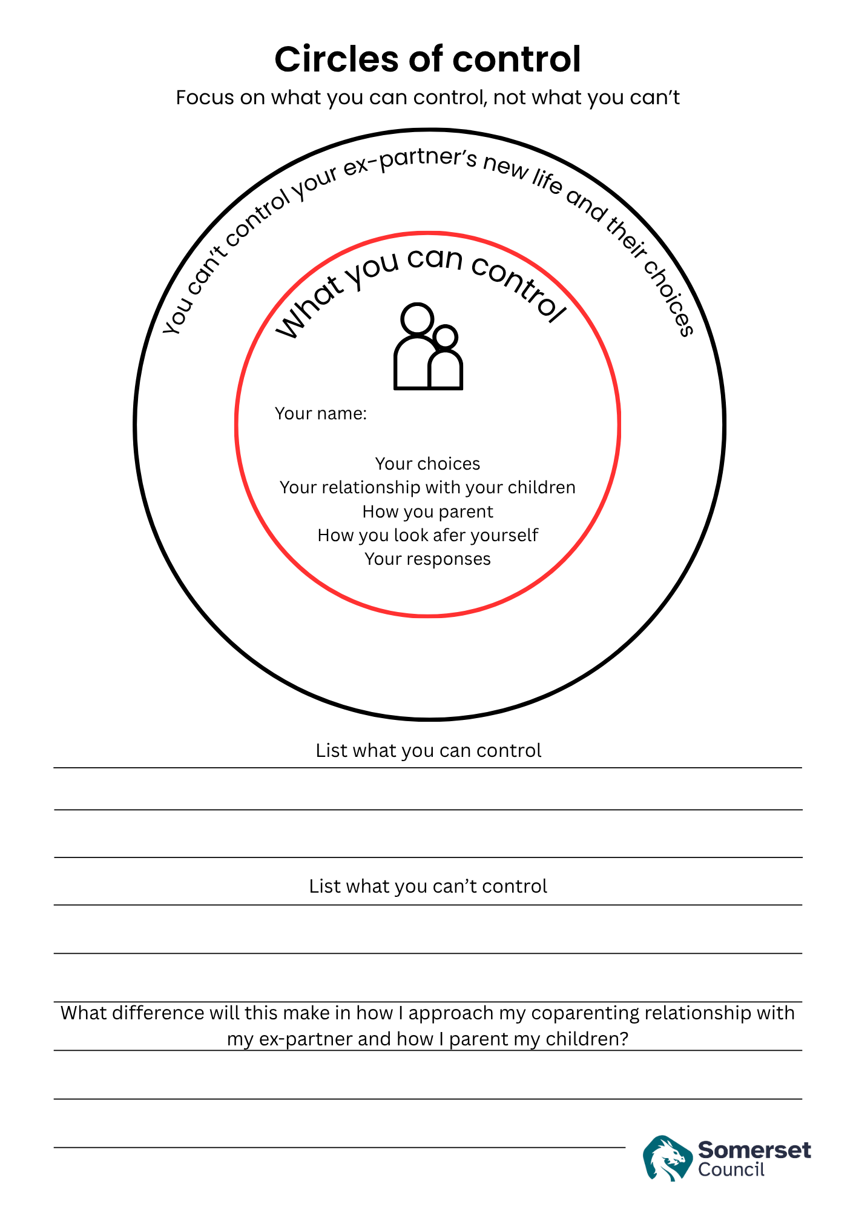
Information sheet: Top tips for improving coparenting communications
As separated parents you need to move from having an intimate relationship to having a business-like relationship with your ex-partner which is focused on facts and not emotions. Please find below a business-like approach to coparenting communications: *BIFF communications approach for coparenting for all written communications, texts and emails to your co-parent.
Try it, practice it, and use it in every written communication with your co-parent.
Step 1: Decide whether you need to respond or not.
Step 2: If you need to respond, slow it down and respond instead of reacting. Use this format:
- Brief: keep it brief. You don’t need to respond to every accusation or allegation. Only response to anything that requires a response to get something done, like picking a meeting spot. Recommended: 1 paragraph of 2-5 sentences maximum – if it’s more, cut it down.
- Informative: when you’ve narrowed down what you absolutely need to respond to, keep your response factual and informative. Remove judgement, blame, accusations, and hostility from your response. Just stick to boring, basic facts.
- Friendly: keep the tone friendly. Not over-the-top friendly but just keep it friendly non-threatening tone with politeness. Use thank you, please and use empathy attention and respect when you can.
- Firm: keep it firm does not mean using threats or big demands. The goal of keeping it firm is to end the conversation and stop further emails or texts on the topic. Instead, you may be setting a boundary or closing the conversation by keeping it firm. Then if they write back, you don’t have to respond. If you need to continue the communication, give 2 options for them to choose from and set a reply by date.
Step 3: Check to ensure you haven’t used one or more of the 3 A’s: advice, admonishment, apologies.
- Advice just brings up your co-parent’s defences.
- Admonishments (when you criticise your coparent) do the same.
- Apologies make them feel like they’re completely right and you are completely wrong. Just avoid them.
Step 4: Wait to send it until you’ve had time to reconsider it after a period of time. By the time you look at it again, your emotions may be lower, and you’ll see it more clearly. Emotions can disproportionately influence communications. You want to respond with logic instead of emotion.
*Taken from The high-conflict co-parenting survival guide by Megan Hunter & Andrea La Rochelle (2019)
Excellent AI tools from Relate: http://www.relate.org.uk/reducing-parental-conflict
Sounding board bot: Made for parents who are having disagreements, this tool helps you write emails, text messages, or get ready to talk with your partner or co-parent. It helps you keep your messages clear, polite, and positive.
The 'in the middle' bot is a chatbot that helps you understand how your child sees your relationship. With a small amount of information and zero judgement, you can learn how your child might be feeling.
Questions about your coparenting communications
What are you going to do to improve about your coparenting communications?

When are you going start?

How are you going to keep following BIFF?

Use this AI tool: www.relate.org.uk/reducing-parental-conflict to sense check any messages you send to your ex-partner.
Information sheet: Reducing the impact of separation on children
Below is a summary of what children need and don’t need taken from: www.parentingtogether.gov.wales
What children need:
- To be allowed to distance themselves from their parents’ conflict
- To have a predictable routine with consistent boundaries within the same household
- To know that they have two homes where they belong
- To be able to stay in contact with extended family like grandparents, aunts, uncles and cousins
- To have access to other types of support if they want it
- Have hope for the future
- Above all – to be allowed to be a child.
What children don’t need:
- To hear or see their parents complaining about or blaming each other
- To hear criticisms or negative comments about either parent
- Adult information about the reasons for the separation or details about finances including child support
- To feel that they may be asked to choose one parent over the other
- To pass messages from one parent to the other
- To feel uncomfortable in one parent’s home.
How a child adjusts to the situation depends on the following:
- The level and intensity of conflict
- Loss of contact with a parent, brother, sister, other close family member or friends
- The level of support they get from their parents
- Their parents’ ability to adjust
- Changes in their household’s finances
- The speed and amount of change – new partners, where they live, changing schools, access to friends
- Their personality, age, gender and stage of development.
Talking and listening to children
For any family going through a separation, communication is extremely important. Talking to your child about your separation and listening to them to ensure you understand their needs and concerns are essential skills. Areas covered in this section include:
- When to tell your child about your separation and anticipating questions they may ask you
- Developing your emotional ‘readiness’ and listening to your child
- Understanding your child’s worries and seeing things from their perspective
- Reassuring your child while remaining honest and realistic
- How your child may react depending on their age
- Helping your child maintain relationships with family and friends after a separation.
Typical reaction of children and young people
Here are some typical reactions of children and young people. Remember there are no typical children:
- Clinging to one or both parents
- Being aggressive and blaming one or both parents
- Being very good or misbehaving in the hope that this will bring parents back together
- Rejecting one or both parents
- Being upset or crying
- Behaving differently or having problems at school.
- The way a child responds can depend on how old they are.
Talking to your child:
- Tell your child what’s happening and that it’s not his or her fault
- Tailor the discussion to your child’s age and understanding
- Let him or her know that there will be other times to talk
- Listen and talk to him or her about any feelings
- Don’t ask or expect your child to choose sides
- Try not to argue, make sarcastic remarks or lose your temper in front of your child.

Some of the questions that your child might want answers to are:

- “Will I be able to see my grandparents?”
- “Where will mum and dad live?”
- “Can I still go to scouts/ youth club/ friends’ houses?”
- “Who will I live with?”
- “Do I have to change schools?”
- “Where will my pet live?”
- “What about the holiday we were going on

Remember
Most children will be OK and small changes in your behaviour can make a big difference.
Your relationship as a couple is over but your relationship as parents is not. Whilst you may have separated some time ago, talking to your child is still important and some of the tips may be something to think about doing now.

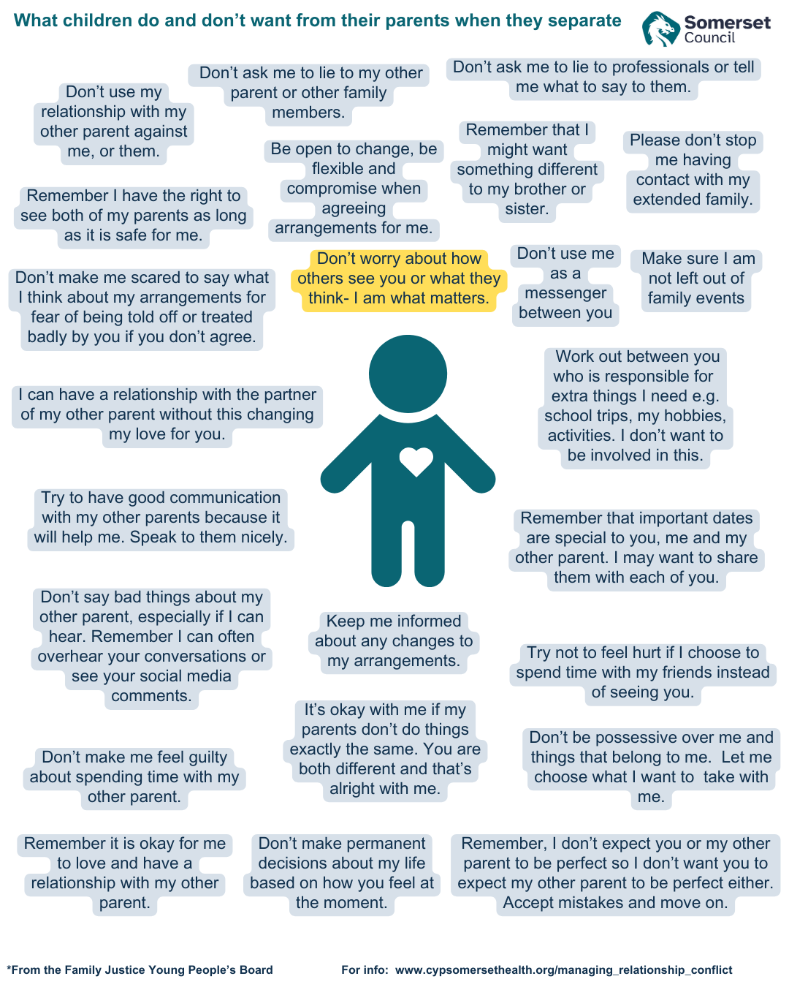
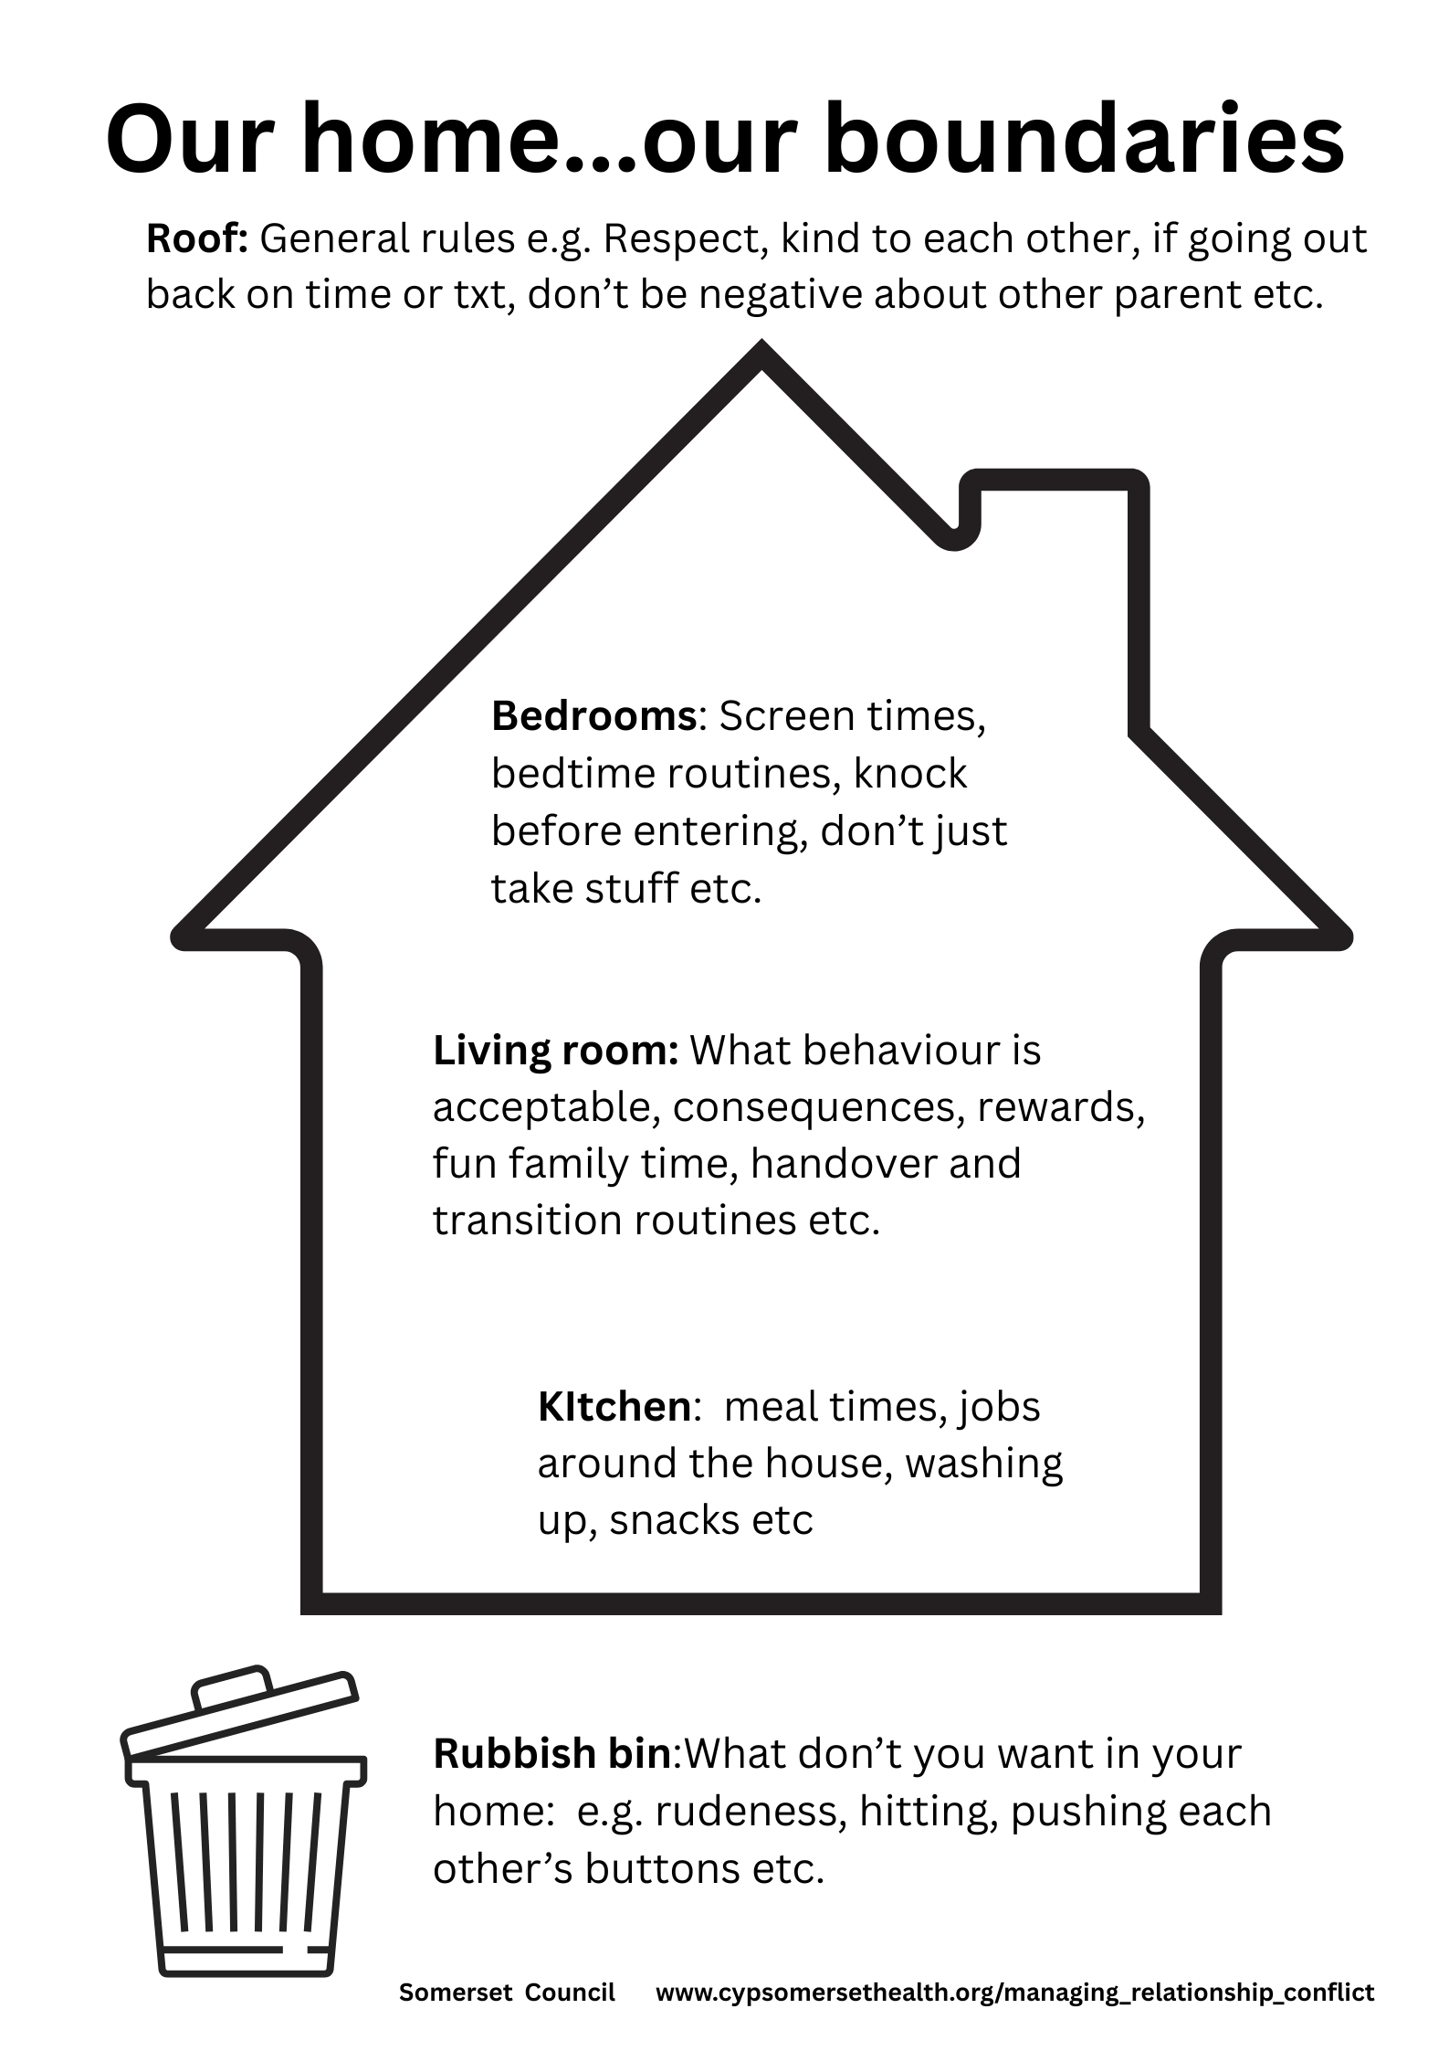
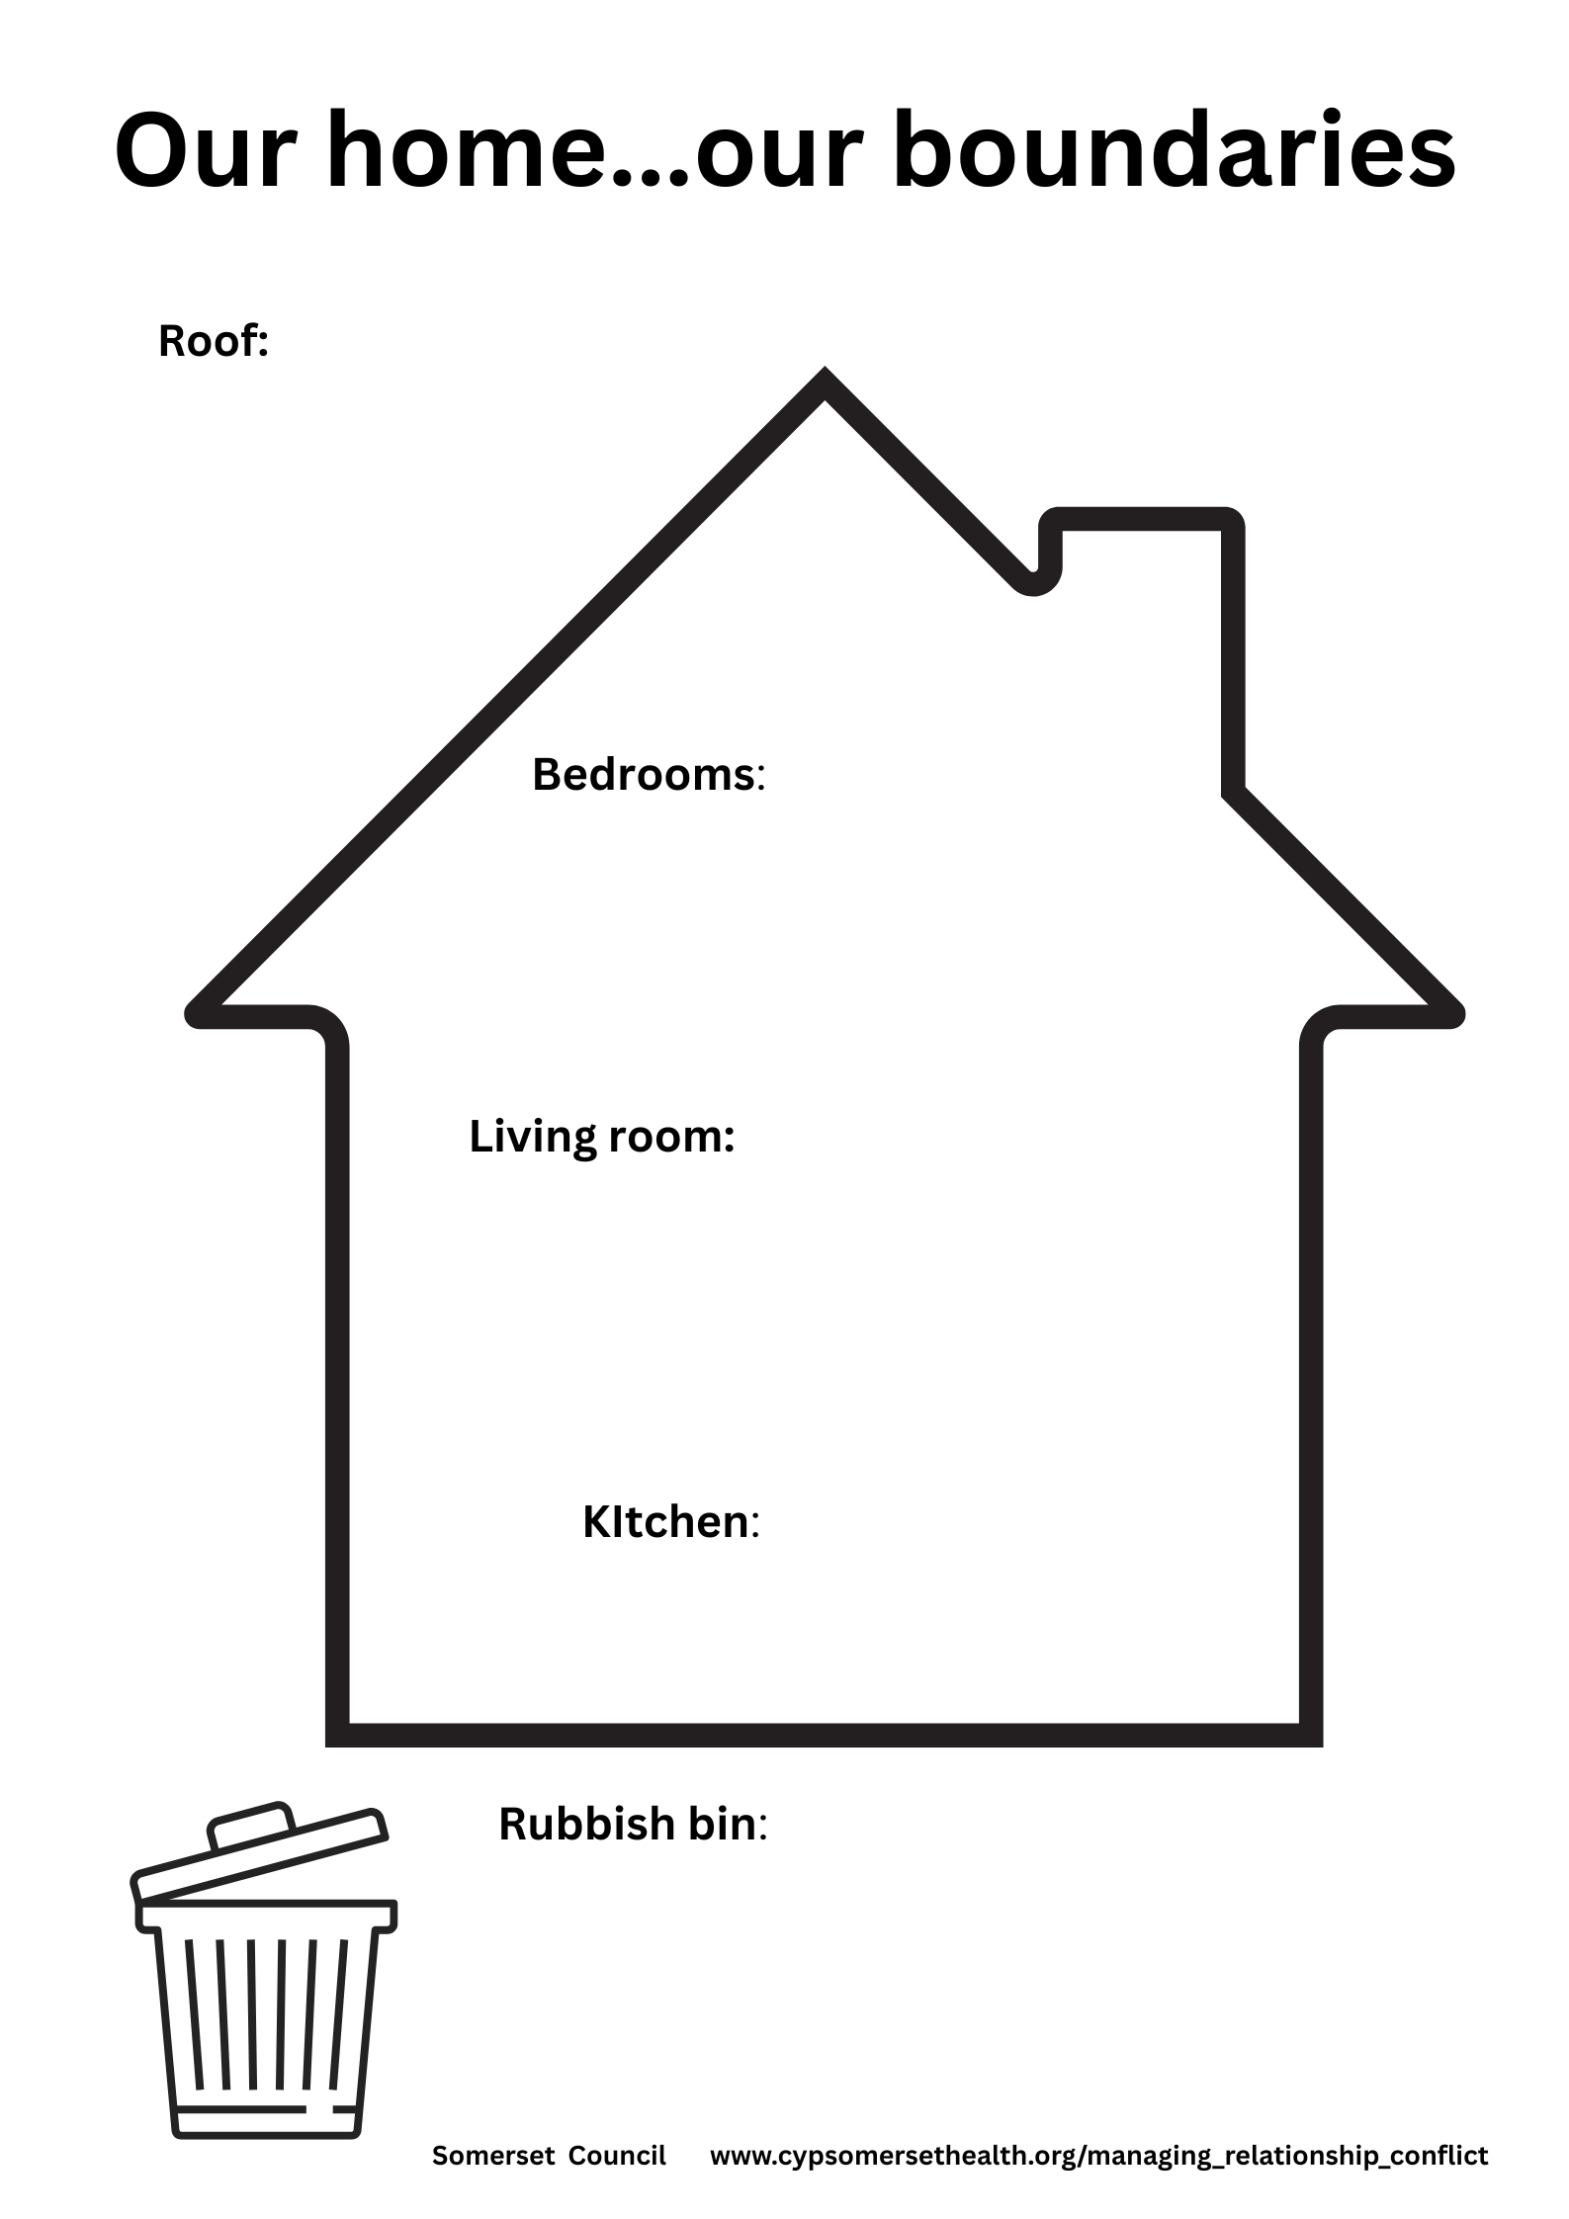

Information sheet: Top tips for smooth handovers and transitions
Things can be made a lot easier for children during contact by having a clear and predictable routine about when, where, and how contact happens.
Contact can run much more smoothly when your children have enough time to prepare and enough time on return to talk with you about how it went. It is important for parents not to allow their own feelings to get in the way of contact.
Here are some top tips for managing handovers and transitions between separated parents to help reduce stress and support children’s emotional well-being:

1. Prioritise the child’s needs
- Keep the focus on what’s best for the child, not on past conflicts.
- Ensure handovers are calm, predictable, and child centred.
2. Be consistent
- Stick to agreed schedules and routines to give children a sense of security.
- Use a shared calendar or parenting app to avoid confusion.
3. Choose neutral locations (if needed)
- If tensions are high, consider meeting in a neutral, public place like a school, park, or family centre.
4. Keep communication calm
- Avoid arguing or discussing sensitive issues during handovers.
- Use written communication (texts, emails, apps) for logistics if face-to-face is difficult.
5. Prepare the child
- Give children age-appropriate information about the transition.
- Help them pack and talk positively about their time with the other parent.
6. Be punctual and reliable
- Arrive on time and be dependable—this builds trust and reduces anxiety for the child.
7. Encourage a positive attitude
- Speak respectfully about the other parent in front of the child.
- Support the child’s relationship with both parents.
8. Allow time to adjust
- Give children space to settle in after transitions—don’t bombard them with questions.
- Be patient with emotional ups and downs.

Top tips for smooth handovers and transitions for your children

Sample routine for contact:
- Remind children that they are seeing their other parent tomorrow.
- Help children prepare their bags and talk about the plan.
- Pass on any relevant information to their other parents via agreed means.
- On your child’s return, set aside time for them to settle back into your home.
- Listen to the other parent about how the contact has gone using the agreed means.
- Allow your child to talk about their visits with the other parent.

Here are some common challenges children and parents face during transitions between separated households:

1. Emotional ups and downs
- Children may feel sad, anxious, or angry before or after a handover.
- They might struggle with loyalty conflicts, feeling guilty for enjoying time with one parent.
2. Adjustment fatigue
- Moving between homes can be physically and mentally tiring, especially if routines differ.
- Children may need time to reorient themselves after each transition.
3. Inconsistent rules and routines
- Different parenting styles or household rules can cause confusion or frustration.
- Children may test boundaries or feel unsettled by the lack of consistency.
4. Communication breakdowns
- Poor communication between parents can lead to missed information, forgotten items, or schedule mix-ups.
- Children may feel caught in the middle or used as messengers.
5. Parental conflict
- Tension or arguments during handovers can be distressing and make children dread transitions.
- Even subtle hostility can impact a child’s sense of safety.
6. Missing belongings
- Forgotten schoolwork, clothes, or comfort items can cause stress or disruption.
- Children may feel unprepared or uncomfortable in one home.
7. Resistance to change
- Some children may resist going to the other parent’s home, especially if they’re more attached to one environment or are experiencing emotional distress.

Managing transitions with your children
1. Talk about the transition in advance
- Give your child a heads-up about when and where the handover will happen.
- Use a calm, positive tone to reduce anxiety and build predictability.
2. Tune into their feelings
- Let them know it’s okay to feel sad, excited, nervous, or even conflicted.
- Say things like, “It’s normal to miss me when you’re away, and I’ll miss you too.”
3. Create a goodbye ritual
- Develop a simple, comforting routine like a special hug, a phrase, or a small note in their bag.
- Rituals help children feel secure and connected, even when apart.
4. Use visual aids
- A calendar or visual schedule can help younger children understand when they’ll see each parent.
- Mark special events or transitions to give them a sense of control.
5. Let them pack a comfort item
- Encourage them to bring a familiar toy, blanket, or photo to ease the transition.
- This provides emotional continuity between homes.
6. Stay calm and reassuring
- Children often mirror your emotions. If you’re calm and confident, they’re more likely to feel safe.
- Avoid showing stress or frustration during the handover.

7. Offer connection while apart
- Let them know they can call or message the other parent if they want to.
- This reassures them that both parents are still emotionally available.

Helping a child manage anxiety during transitions between separated parents involves a mix of emotional support, practical strategies, and consistency. Here are some suggestions:

1. Acknowledge and normalize their feelings
- Let your child know it’s okay to feel nervous, sad, or unsure.
- Use phrases like: “It’s normal to feel a bit worried when things change.”
2. Practice calming techniques
- Teach simple breathing exercises, mindfulness, or grounding techniques.
- Try a “calm-down kit” with items like a stress ball, colouring pages, or a favourite book.
3. Use visual schedules
- A weekly calendar showing when they’ll be with each parent can reduce uncertainty.
- Include fun events or routines to give them something to look forward to.
4. Create predictable routines
- Keep routines consistent across both homes (meals, bedtime, screen time).
- Predictability helps children feel safe and in control.
5. Encourage open communication
- Let them talk about their worries without trying to “fix” everything right away.
- Ask open-ended questions like: “What part of the transition feels hardest?”
6. Offer connection tools
- Allow them to call or message the other parent if they’re missing them.
- A photo or small item from the other home can also provide comfort.
7. Involve them in the process
- Let them help pack their bag or choose a comfort item to bring.
- Giving them small choices can increase their sense of control.
8. Stay calm and reassuring
- Your calm presence helps regulate their emotions.
- Avoid showing stress or frustration during handovers.

Child-friendly activities that can help ease anxiety during transitions between separated parents:

Creative & Calming Activities
1. Draw or colour feelings
- Let your child draw how they feel about the transition.
- Use colouring books or calming mandalas to help them relax.
2. Create a transition journal
- A small notebook where they can write or draw about their day, feelings, or what they’re looking forward to.
- Can be taken between homes to provide continuity.
3. Make a “Feel-Good” Box*
- Fill a small box with comforting items: photos, notes from each parent, fidget toys, or a favourite scent.
4. Breathing games
- Try “bubble breathing” (pretend to blow bubbles slowly) or “smell the flower, blow out the candle” to calm nerves.
5. Yoga or stretching
- Simple poses like “child’s pose” or “tree pose” can help release tension.
6. Go for a walk or bike ride
- Physical activity helps reduce anxiety and gives space to talk naturally.
7. Read a story together
- Choose books about emotions, family changes, or resilience.
- Reading together offers comfort and a chance to talk.
8. Record a message
- Let your child record a short voice or video message for the other parent.
- Helps maintain connection and eases separation anxiety.
9. Play a game
- Board games, puzzles, or card games can shift focus and reduce stress.
10. Create a countdown calendar
- Mark days until they see the other parent again with stickers or drawings.

*Creating a feel-good box is a great way to help your child manage anxiety and feel comforted during transitions. Here's a simple guide to making one:
Step 1: Choose a container
- Use a small box, shoebox, or even a decorated tin or pouch.
- Let your child decorate it with stickers, drawings, or their name to make it personal.
Step 2: Add comfort items
Include things that help your child feel safe, calm, and connected:
- Soft toy or blanket – something familiar and soothing
- Photo of family or pet – for emotional connection
- Notes from each parent – short messages of love or encouragement
- Music playlist or calming sounds – on a device or written list
- Small book or comic – something light and comforting
- Colouring pages and crayons – for creative expression
- Stress ball or fidget toy – to help with nervous energy
- Scented item – like a lavender sachet or parent’s perfume dabbed on fabric
Step 3: Include transition tools
- A mini calendar to track time with each parent
- A feelings journal or notebook
- A contact card with phone numbers or a note saying when they can call
Step 4: Talk about it together
- Explain that the box is there to help them feel better when they’re missing someone or feeling unsure.
- Encourage them to use it whenever they need comfort.

Tips for Managing the Transition Home
Helping your children transition smoothly back to your home after time with your ex-partner can make a big difference in their emotional well-being. Here are some suggestions:

1. Create a calm, welcoming environment
- Greet them warmly but gently—avoid overwhelming them with questions.
- Let them settle in at their own pace with a familiar routine or quiet activity.
2. Offer a “reconnection ritual”
- Have a simple, comforting routine like a shared snack, walk, or reading time.
- This helps re-establish your bond and signals emotional safety.
3. Be emotionally available
- Let them know you’re there if they want to talk, but don’t pressure them.
- Use open-ended prompts like: “How was your weekend?” or “Anything fun happen?”
4. Respect their mixed emotions
- Children may feel happy, sad, or conflicted after a visit—this is normal.
- Validate their feelings without judgment: “It’s okay to miss both homes.”
5. Stick to familiar routines
- Resume your usual routines (meals, bedtime, etc.) to provide stability.
- Predictability helps reduce anxiety and re-establishes a sense of control.
6. Avoid interrogation or negative talk
- Don’t quiz them about the other parent or make them feel like they’re “reporting back.”
- Keep your tone neutral and supportive.
7. Use a transition activity
- Offer a calming activity like drawing, journaling, or a walk to help them decompress.
- Some children benefit from a “transition time” before jumping into homework or household jobs.
8. Watch for signs of stress
- Look for changes in mood, sleep, or behaviour that may signal anxiety.
- If needed, gently check in or consider professional support.
9. Use “Our home… Our boundaries” to remind them they are back home, how you live together in your home and what is coming up.
Personal reflection

Think about your current handover and transition routine for each of your children.

What isn’t working?

What would you like to change and when?

Information sheet: Handover and transition checklist for separated parents

Packing Essentials
☐ School bag, homework, books
☐ Clothes (including weather-appropriate items)
☐ Toiletries and personal care items
☐ Comfort items (stuffed animal, blanket, etc.)
☐ Medications (with instructions)
☐ Electronics and chargers (if allowed)
☐ Special items (sports gear, musical instruments, etc.)

Emotional Preparation
☐ Talk positively about the upcoming transition
☐ Reassure the child they are loved by both parents
☐ Allow the child to express feelings or ask questions
☐ Give them a heads-up about the schedule or any changes

Logistics & Communication
☐ Confirm handover time and location
☐ Share any important updates (school events, health issues)
☐ Use a shared calendar or app to track schedules
☐ Avoid discussing conflicts during the handover

Settling In at the Other Home
☐ Allow time for the child to adjust and settle
☐ Keep routines consistent (meals, bedtime, etc.)
☐ Encourage the child to contact the other parent if they wish
☐ Be patient with mood changes or clinginess

Managing the Transition Home
☐ Create a calm, welcoming environment
☐ Offer a reconnection ritual (snack, walk, story)
☐ Be emotionally available without pressure
☐ Respect mixed emotions
☐ Stick to familiar routines
☐ Avoid interrogation or negative talk
☐ Use a transition activity
☐ Watch for signs of stress

And finally… What are you bonding with your children over?
- Do you gossip with your children about their other parent?
- If your child can keep you worked up, that can work for their benefit e.g., extra attention, sympathy, treats etc.
- When you stop reacting and stop feeding attention to the other parent every time they do not show up for your children, you stop being manipulated and your relationship with your children will shift.
- Once your child no longer has the option to form an emotional connection with you over complaining about the other parent, they will begin to value the time with you and your relationship will improve.
- Choose what you want to bond with your children over.

Information sheet: Signposting to support websites
All support websites for separated parents: www.cypsomersethealth.org/support_for_separated_parents
Courses for separated parents living in Somerset: https://www.cypsomersethealth.org/?page=events__parenting_cafes_and_parenting_when_separated_courses
Live chat facility for parents with Corum family lives: https://www.coramfamilylives.org.uk/
Plain English legal library: https://courtney.legal/
Family Separation Support Hub: www.familyseparationsupporthub.org/
Excellent Australian website for parents 0 to adult children: www.raisingchildren.net.au/
FREE parenting courses for Somerset parents using DRAGON code: www.learn.inourplace.co.uk/online-learning/
Emotion coaching: www.cypsomersethealth.org/emotion_coaching

Information sheet: Top tips for blended families

Transitioning to a blended family can be both rewarding and challenging. Here are some top tips to help make the process smoother for families in the UK:
- Communicate openly:
  - Ensure open and honest communication with your partner and children. Discuss expectations, concerns, and feelings regularly [1].
- Be patient:
  - Understand that blending families takes time. Be patient with each other as everyone adjusts to the new family dynamics [2].
- Create new traditions:
  - Establish new family traditions and rituals that everyone can look forward to. This helps in building a sense of unity and belonging [1].
- Respect each other’s roles:
  - Acknowledge and respect each person’s role within the family. This includes respecting the parenting styles and boundaries of each parent [3].
- Hold family meetings:
  - Regular family meetings can help address any issues and ensure everyone feels heard. This fosters a sense of inclusion and teamwork [2].
  - Try using the tool on Page 13
- Spend quality time together:
  - Try to spend quality time together as a family and individually with each child. This helps strengthen bonds and ensures everyone feels valued [2].
- Acknowledge and address loss:
  - Recognize that members of blended families may carry feelings of loss from previous relationships. Be supportive and understanding of these emotions [2].
- Seek professional help if needed:
  - If you encounter significant challenges, don’t hesitate to seek help from a family therapist. They can provide valuable guidance and support [1].
References
[1] Blended Families: A Guide to Success - Parenting Expert
[2] 10 top tips for creating a healthy blended family - Care for the Family
[3] What Is a Blended Family? A Guide for Separated Parents

Suggestions for managing behaviour in a blended family
Handling behaviour in a blended family can be complex, but with the right approach, it can be managed effectively. Here are some tips to help:
- Communicate and agree on discipline strategies:
  - Before implementing any behaviour management approaches, ensure that both partners are on the same page regarding rules and consequences. Consistency is key.
- Let the biological parent take the lead initially:
  - In the beginning, it's often best for the biological parent to handle most of the discipline. This helps the children adjust and build trust with the stepparent.
- Maintain a united front:
  - Present a united front to the children. Discuss and resolve any disagreements about discipline in private to avoid undermining each other.
- Respect each other’s roles:
  - Acknowledge and respect each person’s role within the family. This includes respecting the parenting styles and boundaries of each parent.

- Build strong relationships:
  - Focus on building strong, positive relationships with the children. This foundation of trust and respect will make discipline more effective.
- Be consistent:
  - Consistency in rules and consequences is crucial. Ensure that all children, whether biological or step, are treated equally.
- Use positive reinforcement:
  - Encourage good behaviour with positive reinforcement. Praise and rewards can be more effective than punishment in promoting desired behaviours.
By following these tips, you can create a harmonious and supportive environment for your blended family. How are you currently managing discipline in your family?
References
[1] Discipline in Blended Families: 5 Keys to Success
[2] Establishing Discipline in the Blended Family Home

Information sheet: Tips on navigating coparenting for separated parents living in the same home

Co-parenting while living together can be tricky, but with the right approach, you can learn to manage it for yourselves and your children. Here are some tips to help navigate this situation:

Think about having a family meeting
Firstly, go through the list below and work out what you both need to talk about. Then sit down and talk through the points together. Once you have reached an amicable agreement, think about organising a family meeting with both you and your children to work out how you are going to live together. Share notes on what you agree/draw a picture and review this at regular family meetings. You could even try a “Our home… Our boundaries” exercise (P 13) if it can be undertaken without conflict and in a calm atmosphere with your children.

- Prioritize your child's needs: always keep your child's well-being at the forefront. Ensure they feel secure and loved despite the changes.
- Communicate effectively: decide how you are going to communicate and remember biff. Try to establish a business -like relationship. Regularly discuss any issues related to coparenting and living arrangements.
- Redefine your relationship: shift your focus from being partners to being coparents. Establish a new way of parenting together but separately that centres around your child's needs.
- Split responsibilities: clearly divide parenting duties and household chores. This helps avoid conflicts and ensures both parents are equally involved.
- Maintain consistent routines: keep consistent rules and routines for your child. This stability is crucial for their emotional well-being.
- Establish clear boundaries: set clear boundaries regarding personal space and privacy. Respect each other's need for alone time.
- Respect each other's space: give each other time and space to recharge. This can help reduce tension and maintain a peaceful environment.
- Create a parenting schedule: develop a clear schedule for parenting duties. This helps manage time effectively and ensures both parents are involved.
- Establish separate spaces if you can: designate specific areas in the house for each person to have their own space. This can help create a sense of privacy and independence.
- Focus on solutions: instead of dwelling on problems, focus on finding practical solutions that work for both parties
- Resolving conflicts effectively is crucial for maintaining a peaceful environment while co-parenting in the same house.
- Take breaks: if a discussion becomes heated, take a break to cool down before continuing. This can prevent arguments from escalating
- Agree on rules: set clear rules for household responsibilities and parenting duties. This helps avoid misunderstandings and ensures fairness.
- Focus on the future: keep in mind that this arrangement is temporary. Focus on the long-term goals and the well-being of everyone involved
- Practice empathy: try to understand each other's feelings and perspectives. Empathy can help reduce tension and foster cooperation
- Reset your relationship dynamic and be businesslike how you approach facts your coparenting: keep your interactions focused on facts and information, keep them brief and polite.
- Set house rules: agree on house rules related to guests, who does what chores, and shared spaces to ensure the household run smoothly and everyone’s needs are met.
- Respect each other’s privacy: this is especially in respect of personal belongings, mail and digital communications. Privacy is crucial for individual peace of mind.
- Plan for time apart: schedule time outside the home to pursue your own interests, socialise with friends or simply enjoy time alone. This is essential for your emotional.
- Discuss new relationships: have a conversation about how to handle new romantic relationships, including introductions to children and overnight guests, to manage potential awkwardness or her feelings.
- Seek support: don’t hesitate to seek support from friends, family or professionals to navigate the emotional complexities of living together after separation.
- Revisit the arrangement regularly: periodically review the living arrangements to ensure it is still working for both parties and adjust as needed.
- Focus on the future: keep the bigger picture in mind and use this time to prepare for the eventual physical separation such as saving money, looking for new housing etc.

Information sheet: Tips on what to do when a child resists going to their other parent’s home.
1. Stay calm and curious
- Gently ask your child why they don’t want to go—without judgment or pressure.
- Use open-ended questions like:
“Can you tell me what’s making you feel that way?”
2. Validate their feelings
- Acknowledge their emotions, even if you can’t change the situation. Remember all emotions are okay just not all behaviours:
“It sounds like you’re feeling nervous. That’s okay.”
3. Look for patterns or triggers
- Is it always after a certain event?
- Are there issues like boredom, conflict, or missing routines?
4. Reassure and prepare
- Remind them they are loved by both parents.
- Talk positively about their time with the other parent.
- Help them pack something comforting (a toy, photo, or note).
5. Stick to the agreed plan
- Unless there are safety concerns, follow the parenting agreement.
- Consistency helps children feel secure, even if they resist at first.
6. Avoid negative talk about the other parent
- Children may feel torn between parents. Stay neutral and supportive.
- Avoid making them feel guilty for spending time with the other parent.
7. Seek support if needed
- If resistance is ongoing or intense, consider involving a professional.

If your child outright refuses to go to your ex-partner’s home, it’s important to respond with empathy, consistency, and care.

Here’s a step-by-step approach:

1. Stay Calm and Supportive
- Avoid reacting with frustration or guilt.
- Gently acknowledge their feelings:
“I can see this is hard for you. I’m here to help.”
2. Explore the Reason (Privately)
- Ask open, non-leading questions:
“Can you help me understand what’s making you not want to go?”
- Look for signs of:
  - Fear or discomfort
  - Conflict or tension at the other home
  - Missing routines or belongings
  - Feeling torn between parents
3. Respect Legal Agreements (Unless Safety Is a Concern)
- If there’s a court order or parenting plan, you’re generally expected to follow it.
- If your child refuses to go, document the situation and your efforts to encourage them.
- Do not force them physically—this can escalate distress

5. Collaborate with the Other Parent
- If possible, work together to understand and address your child’s concerns.
- Avoid blame—focus on solutions and emotional safety.
6. Rebuild Trust and Comfort
- Use gradual exposure if appropriate (e.g., shorter visits, meeting in neutral places).
- Let your child bring comfort items or stay in touch with you during visits.
7. If You Suspect Harm or Neglect
- If your child’s refusal is due to fear, abuse, or neglect, contact Somerset Direct on 0300 123 2224 for further advice and support.

Information sheet: Self-reflection: Does your attitude help or hinder you?
Use this questionnaire as an opportunity to reflect on whether you feel your attitude helps or hinders you in managing your coparenting relationship with your ex-partner in a way that protects and improves the well-being of your children.
 | Question | Yes | No
1 | You constantly blame other people in situations
2 | You have a “life is against me” attitude
3 | You are regularly cynical or pessimistic
4 | You fall into thinking traps, such as catastrophising and “me, me, me” and “them, them, them” thinking
5 | Even when things go right, you find something to complain about.
6 | You complain that other people are better off than you.
7 | You struggle to appreciate other perspectives.
8 | You are uncooperative when people try to help you with your problems
9 | You regularly act like you are powerless to change.
10 | You often feel sorry for yourself.
11 | You regularly believe other people have a better life.
12 | You regularly blame your ex-partner for everything negative that has happened to you.
13 | You have friends who complain, blame and feel victimised.
14 | You say you know it all, what to do to make this better but you never do anything about it.
 | TOTAL

Questions
- This my attitude helps or hinder me?
- What small step could I take to change my attitude?
- What difference would this make my myself?
- What difference would it make to my children?

Child first action plan for reducing conflict with your ex-partner.
Name
Date
I am going to do the following to reduce conflict with my ex-partner and improve the situation for my children in the next week:

