Sheet 8: Supporting children through separation – what they need and don’t need
What children need:
- To be allowed to distance themselves from their parents’ conflict
- To have a predictable routine with consistent boundaries within the same household
- To know that they have two homes where they belong
- To be able to stay in contact with extended family like grandparents, aunts, uncles and cousins
- To have access to other types of support if they want it
- Have hope for the future
- Above all – to be allowed to be a child.
What children don’t need:
- To hear or see their parents complaining about or blaming each other
- To hear criticisms or negative comments about either parent
- Adult information about the reasons for the separation or details about finances including child support
- To feel that they may be asked to choose one parent over the other
- To pass messages from one parent to the other
- To feel uncomfortable in one parent’s home.
How a child adjusts to the situation depends on the following:
- The level and intensity of conflict
- Loss of contact with a parent, brother, sister, other close family member or friends
- The level of support they get from their parents
- Their parents’ ability to adjust
- Changes in their household’s finances
- The speed and amount of change – new partners, where they live, changing schools, access to friends
- Their personality, age, gender and stage of development.
Talking and listening to children
For any family going through a separation, communication is extremely important. Talking to your child about your separation and listening to them to ensure you understand their needs and concerns are essential skills. Areas covered in this section include:
- When to tell your child about your separation and anticipating questions they may ask you
- Developing your emotional ‘readiness’ and listening to your child
- Understanding your child’s worries and seeing things from their perspective
- Reassuring your child while remaining honest and realistic
- How your child may react depending on their age
- Helping your child maintain relationships with family and friends after a separation.
Typical reaction of children and young people
Here are some typical reactions of children and young people. Remember there are no typical children:
- Clinging to one or both parents
- Being aggressive and blaming one or both parents
- Being very good or misbehaving in the hope that this will bring parents back together
- Rejecting one or both parents
- Being upset or crying
- Behaving differently or having problems at school.
- The way a child responds can depend on how old they are.
Talking to your child:
- Tell your child what’s happening and that it’s not his or her fault
- Tailor the discussion to your child’s age and understanding
- Let him or her know that there will be other times to talk
- Listen and talk to him or her about any feelings
- Don’t ask or expect your child to choose sides
- Try not to argue, make sarcastic remarks or lose your temper in front of your child.

Some of the questions that your child might want answers to are:

- “Will I be able to see my grandparents?”
- “Where will mum and dad live?”
- “Can I still go to scouts/ youth club/ friends’ houses?”
- “Who will I live with?”
- “Do I have to change schools?”
- “Where will my pet live?”
- “What about the holiday we were going on

Remember
Most children will be OK and small changes in your behaviour can make a big difference.
Your relationship as a couple is over but your relationship as parents is not. Whilst you may have separated some time ago, talking to your child is still important and some of the tips may be something to think about doing now.

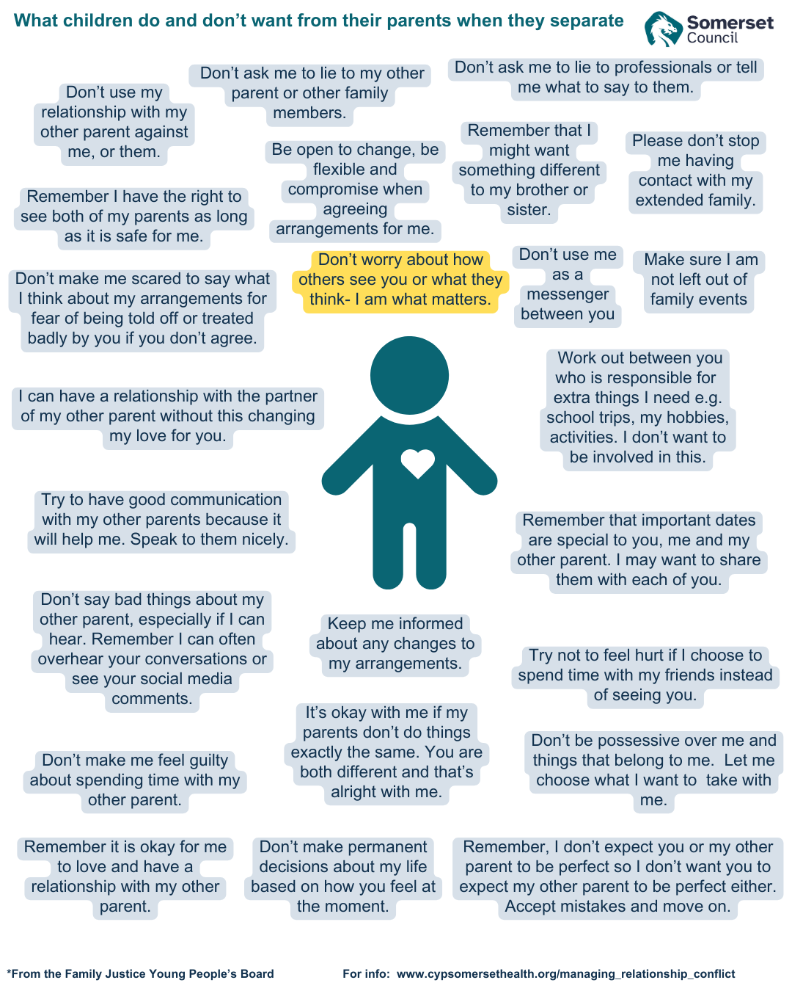
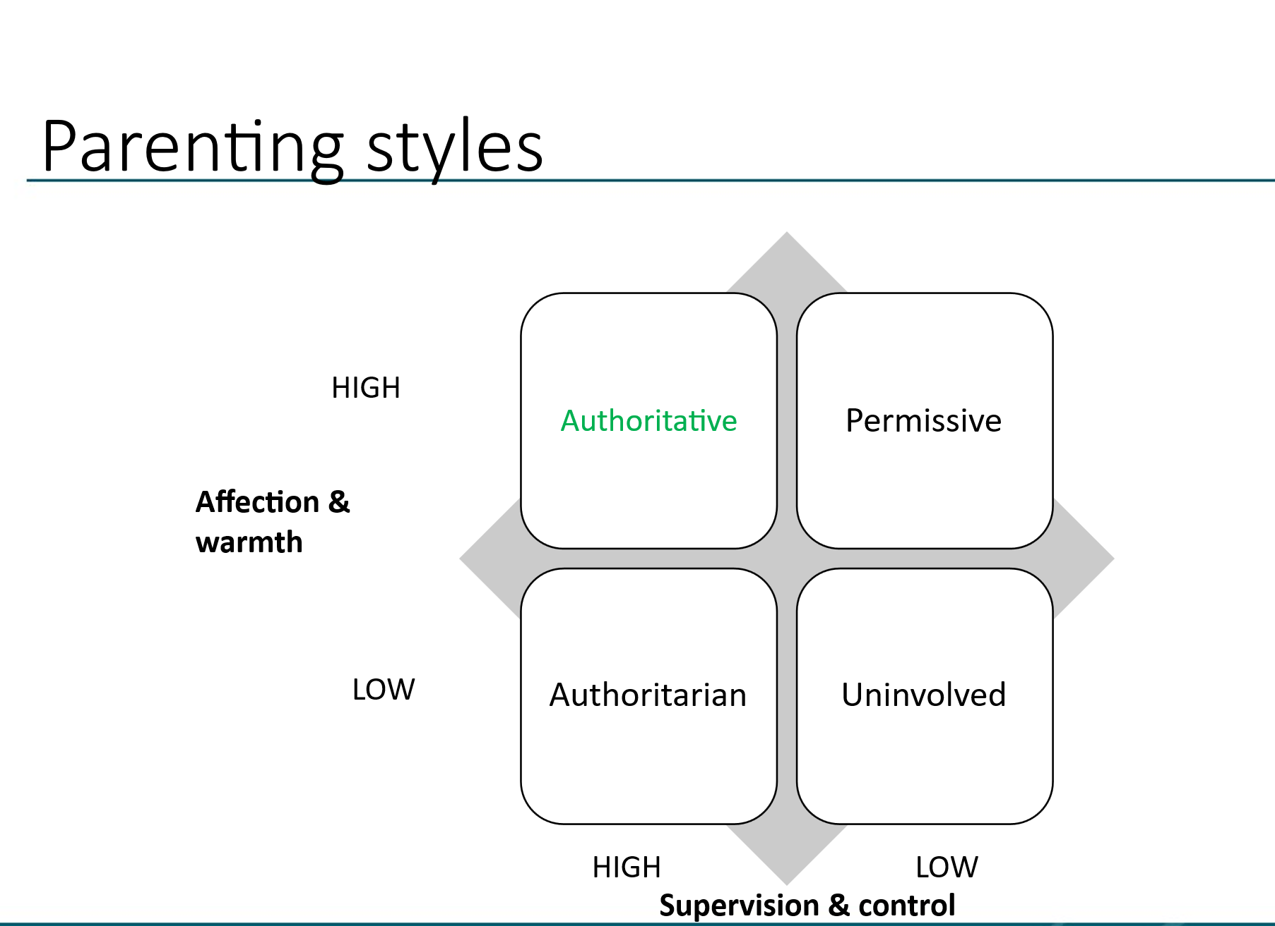
What is your parenting style?

Authoritarian – expects obedience without question, likes to be in control and winning is more important than relationship
Possible effects – being heavy-handed can make behaviour worse, lots of arguments and power struggles, children can feel squashed and fearful, may appear to submit but inwardly resent parent

Permissive – no boundaries, parents who don’t like saying no and dislike confrontation, may feel they’ve lost control, may be too busy with other things to be bothered
Possible effects – child may feel unloved and disconnected, will feel no one really cares, deep down may feel “a bad person” and seek acceptance from gangs and peers, may say or do shocking things to provoke reaction

Uninvolved – there may be emotional detachment, minimal interaction, lack of supervision, no boundaries, may be indifferent or dismissive towards children’s needs and in extreme cases may overlook basic necessities.
Possible effects – This style of parenting can have a significant negative impact on the child’s development e.g. low self-esteem, poor academic performance, poor self-regulation and difficulty forming healthy relationships.

Authoritative/Assertive parenting – reasonable, friendly and fair, have clear expectations, negotiate boundaries, pick their battles and are consistent
Possible effects – children are more likely to feel happy, self-reliant, less vulnerable to risk-taking, popular with peers, confident, have social skills and can set their own standards

What to do if your ex-partner has a different style of parenting to you?

Although you may aim for similar approaches to parenting, the reality may be very different. Therefore, there are some suggestions below:

Children need boundaries
- Having boundaries makes them feel secure but they shouldn’t be too tight or too loose – they need to be flexible and respect age and maturity. Negotiated boundaries work better as they get older.
- Make sure your boundaries are consistent and once set, stick to them. They can change but let your children know what’s going on.
- If you get it wrong, apologise and change.
- Plan digital boundaries to ensure your children are safe online.

Negotiating boundaries – you need to be clear about what your boundaries are, as your children get older you will need to start negotiating boundaries but always remember that you are the parent!

Consistency
Consistency of approach is probably as important as listening/communicating with your child. You need to decide on your approach and be consistent in your messages. If you say "no" makes you stick to it – do not make threats and not carry them through.

How to emotion coach your child:
- Become aware of your child’s emotion, especially if it is of a lower intensity (such as disappointment or frustration)
- View their emotions as opportunities for connecting and teaching
- Listen and accept their emotions: avoid judgement
- Help your team to describe how they feel: verbally label emotions
- If appropriate, help them to problem-solve: negotiate boundaries
Emotion coaching https://www.cypsomersethealth.org/emotion_coaching

Emotion coaching: key pointers
- Accept and acknowledge your child’s feelings
- Maintain boundaries, but negotiate and reduce these as your child grows
- Expect shortness, few words, grunts and displeasure: don’t take it personally
- Avoid reacting out of feeling rejection
- Be around: this allows opportunities to connect when your child is ready
- Step back: “I’ll be there if you need me”

Opportunities to connect
Opportunities to connect are often about finding environments in which your child is more likely to talk to about their emotional experiences. Children will vary in their preferences and when they feel most comfortable e.g.:
- watch a favourite TV show or movie together
- play cards, board or electronic games
- listen to music with them
- arrange a family outing
- take them out for a treat
- use touch and affection where possible
- go shopping, make a meal together, create something together
- talk together if you drive

Sitting with (I think this is the most powerful element)
A key part of Emotion Coaching is being with your child when they are feeling emotions but not having to talk a lot.

The following pointers might help create the right environment for your team to open:
- Show that you are listening with your body language and your non-verbal responses
- Focus on providing non-judgemental support, acceptance and empathy
- Allow time – when your children are emotional, they need to calm down before they can think clearly and rationally. Empathetic, supportive responses from you help them to calm – rather than lots of talking. Empathy is known to soothe fear and anger.
- Sometimes you will need to “zip up your mouth and sit on your hands”.

Emotion coaching conversation starters
NOTE: your non-verbal language just as critical – use nods, silence and pauses to show you are listening. Too much talking can shut your teen down.
- That sounds difficult…
- You look so happy…
- You seem a bit sad…
- Gosh that’s awful…
- Maybe you are cross with her?
- It sounds like you were…

It’s all about having a positive relationship your child and communicating with them
Every good conversation needs to start with good listening – things which blocked good communications include criticising, being bossy, always having the last word, asking too many questions, solutioning and jumping to conclusions

Good listening includes:
- Remain silent most of the time
- Be aware of body language – what makes an impression?
- Show you are listening
- Look but don’t talk
- Try to reflect back what is said
- Avoid offering suggestions/solutions

Talking to our children: always remember the 3 T’s
- Tone – how you say it i.e. don’t screech – tone of voice is like a delivery message for children, it conveys meaning. The tone of many children is to get under their parents’ skin!
- Timing – when you say: pick your moments – wrong moments will never mean a positive outcome/healthy relationship!
- Text – what you say – often with planning difficult conversations in advance if you don’t want to end up in an argument and try not to talk to them about sensitive issues when you’re tired/fed up/bored

Don’t forget the I message
- When You… I Feel… Because…
- I want… I feel… I would appreciate it if… I need… I understood you to say… I thought you said…

How to boost your child’s self-esteem
- Stay connected
- Find something they are good at and build on it
- Treat them with respect
- Understand what it is like for them
- Use words that build up
- Show interest in their lives and have some fun!

Emotional bank account
Deposits | Withdrawals
Keep promises | Struggling with schoolwork
Give encouragement | Not listen to
Discuss their future | Bullied
Family days | Being shouted at a lot
Help with homework | Compare it to another child
One-on-one time | Parents argue/separation
Negotiating going out | Being left out

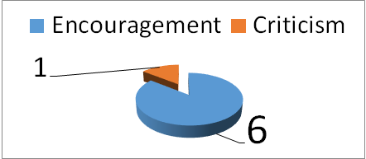
Encouragement to criticism ratio
It is too easy to criticise our children. We need to remember that the research shows that for every word of criticism, there should be 6 words of encouragement! However difficult the situation, try to catch a child doing something good/well. Use every opportunity as an opportunity to connect with them.

Conversations with your children – things that make you feel good
Talk to your child and brainstorm a list of things they do that make them feel good or help them when they are feeling a bit down. Try not to suggest anything yourself but be guided by them – it may take couple of days for them to think about it but encourage them to talk about it.

Love languages https://www.relate.org.uk/get-help/what-are-love-languages

The concept of love languages, introduced by Gary Chapman, identifies five ways people express and receive love. Understanding your child’s primary love language can help strengthen your relationship. There are questionnaires and information online if you are interested.

The love languages are:
.
- One-on-one time
- Words of encouragement and affirmation
- Presents
- Actions i.e. acts of service
- Appropriate touch

