Managing emotions
Being a parent is an emotional rollercoaster as you and partner navigate parenting your children together.
However, learning to manage our emotions as parents helps us to create a stable and supportive environment for our children, helping them cope with the changes and hopefully reducing conflict in your relationship.
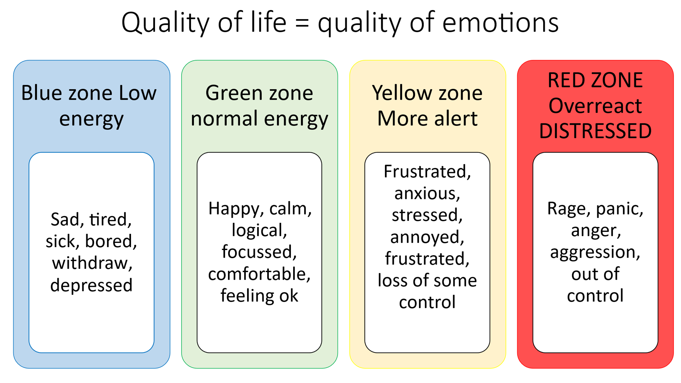
As parents, we set the emotional atmosphere is our homes so what do we need to do to ensure we are able to spend more time in our ‘green zone’ and increase our window of tolerance which will help our children as well as strengthen our relationship with our partner.

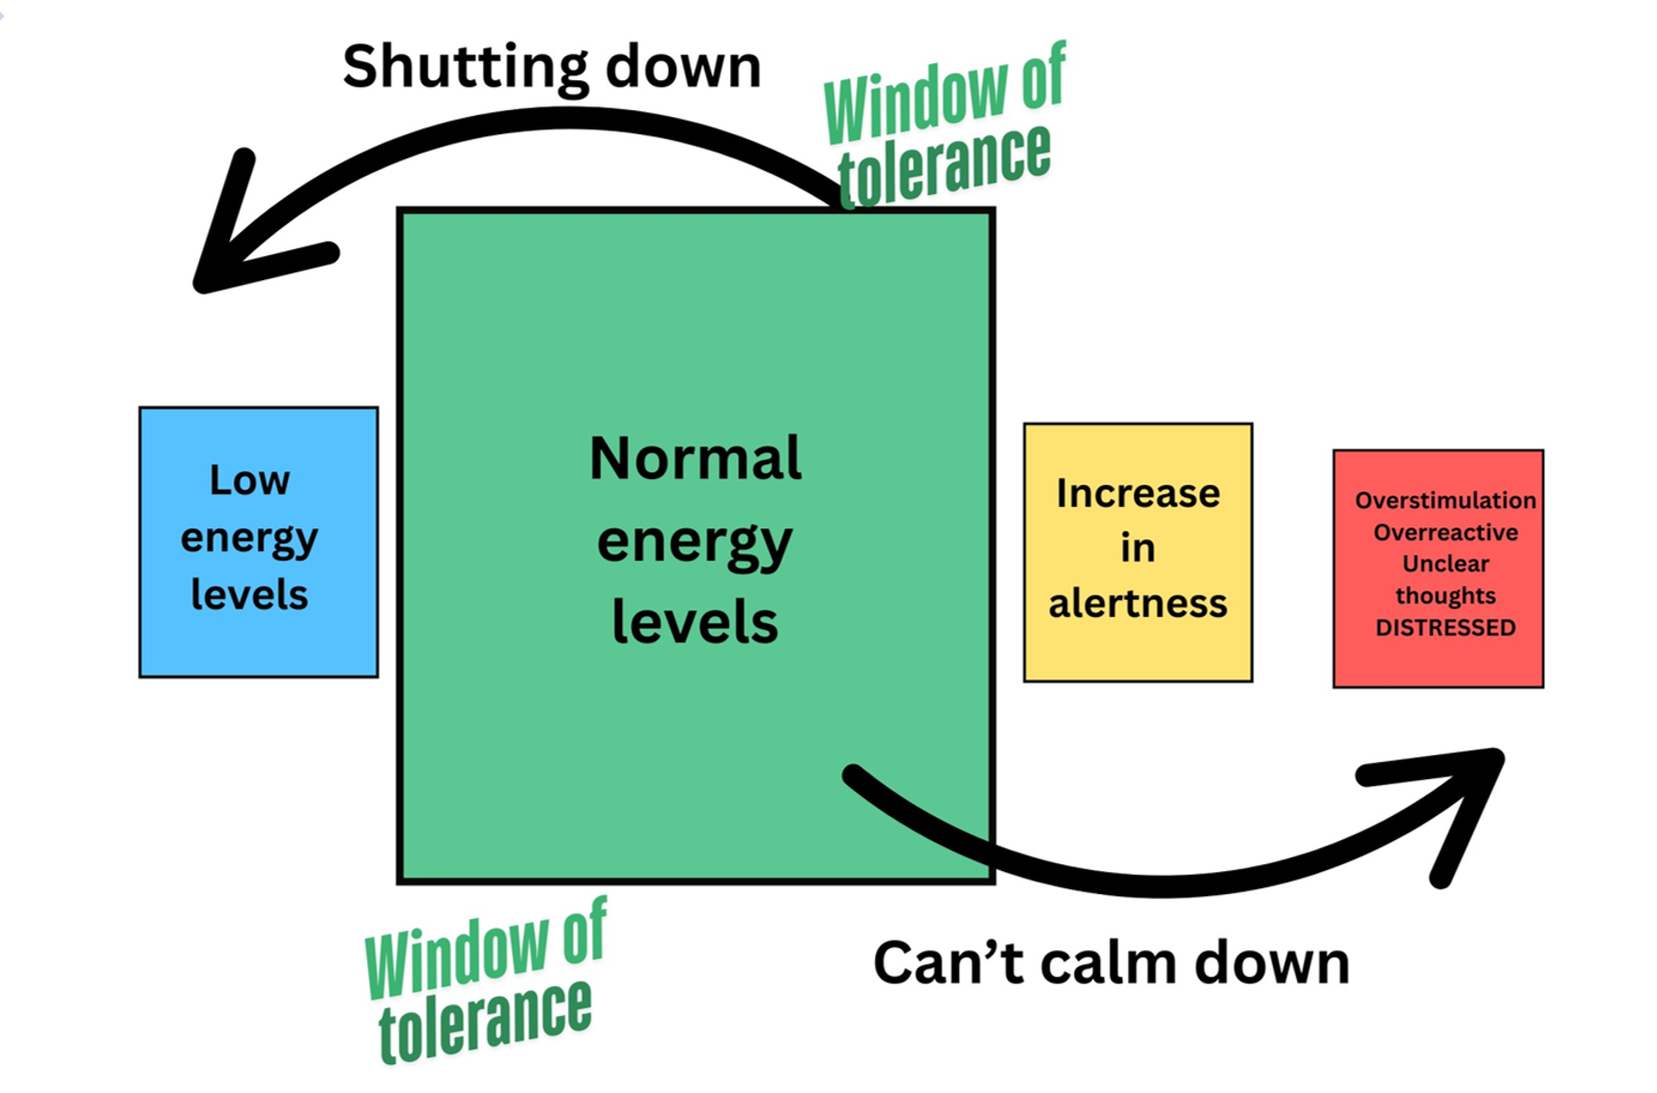

Reflection

- One positive change to help you get back and stay in the ‘Green zone’ and increase your window of tolerance for longer?

- What more could you do to look after yourself in the short, medium and long term? And when are you going to do it?

LINK for more information about emotion coaching: Somerset children & young people : Health & Wellbeing : Emotion Coaching Webinars For Parents And Carers

