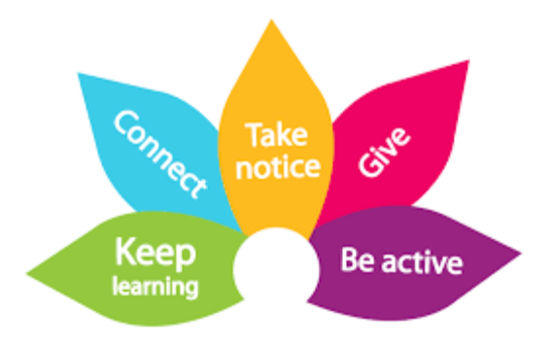

Be Active

We have included ideas which link to the pillars of wellbeing from the Somerset Wellbeing Framework

Take Notice

Information about the Somerset Wellbeing Framework can be found on our website: www.cypsomersethealth.org/new_home



Take Notice…
Reminding yourself to ‘take notice’ can help make you feel better.
Researchers believe that being aware of what is taking place around you improves the way you feel about yourself. Enjoying ‘the moment’ can help you to find out what’s important to you.
Take some time to enjoy the moment and the space around you.

Here are a few ideas:
• Get a plant for your bedroom
• Have a ’tidy your room’ day
• Take notice of how your friends and classmates are feeling or acting
• Look at the sky
• Pick up a stone
• Sit somewhere different to have your lunch

What do you currently do to Take Notice?

What more could you do to Take Notice?

Taking Notice of Ourselves and Nature


As areas start to re-open, we may choose to reflect and notice how life has been over the past few months.
We may consider, what do we want to keep from this time (if anything) – it may be family relationships and connections have strengthened, you may be taking regular exercise or meditation.
It may not be easy to find positives which have come from this time. If this is the case for you, perhaps explore this as a wider, more global consideration.
Reflecting on your experiences will help you appreciate what matters to you.


Taking notice includes Sleep Health
Paying attention to our body and minds may help us to notice our sleep – Do we need more? Do we need better quality? This sleep leaflet from the Mental Health Foundation offers great advice, tips and interesting sleep facts.


Wellbeing and sleep: full works
You may find this podcast presented by Dr David Peters which is intended to be listened to in bed, can help you relax and get ready to go to sleep
https://soundcloud.com/mentalhealthfoundation/wellbeing-and-sleep-full-works


Get out in nature and take notice of all nature's beauty!
Fyne court – is open for access and free to visit a hidden gem in the heart of the Quantock Hills. You can explore this wild garden and discover pieces of its history hiding in the undergrowth.
Visit the website for more information https://www.nationaltrust.org.uk/fyne-court
Important notice - Our car parks are open. We have limited spaces, so if the car park is full please come back another time!


Nurture a plant
With the re-opening of garden centres and many supermarkets selling plants take some time to nurture a house plant.
Take notice of some of the benefits which a houseplant can bring to a home:
- Boost mood, productivity, concentration and creativity
- Reduce stress
- Clean indoor air by absorbing toxins, increasing humidity and producing oxygen

A to Z of mindfulness in nature

Explores just some of the ways that our countryside and its wildlife can improve both your physical and mental health.
There are an increasing number of studies, backed by scientific research, that suggest that slowing down and being more present can help alleviate feelings of anxiety, depression and stress.
www.countryfile.com/how-to/a-to-z-of-mindfulness-in-nature/

All Things Mindful
To help you take notice of you, we have put together some mindfulness practices from renowned Mindfulness teachers or organisations


 Stop, Breathe & Think
In this video, strengthen your superpowers of focus and calm by taking slow deep breaths as you trace the outline of your hand with your pointer finger.

Body Scan Practice with Elisha Goldstein
This is a 10 minute practice to bring with you anywhere and anytime to begin training your mind to be more present to your life and recognize more clarity, opportunity, possibility and choice.



Mindful Eating
Smiling Mind invites us to practice mindful eating in 5 steps. Mindful eating is eating with intention whilst paying attention.
blog.smilingmind.com.au/how-to-practice-mindful-eating-in-5-steps

Mindful Walking Practice

We often take walking for granted, if we can slow down, and tune into all the physical and emotional qualities walking brings; we may find a lot more is going on in our bodies and minds.
Enjoy a few moments to experience a guided mindful walk
https://jackkornfield.com/walking-meditation-2/

The Chocolate Meditation

Connecting with your senses is one of the core benefits of Mindfulness meditation. Many traditions use nuts or fruit as the focus for a meditation on the senses of taste, smell and touch. But you can use any food at all so here is a meditation based on chocolate. Why not do it now by clicking on the link below?
soundcloud.com/hachetteaudiouk/mindfulness-the-chocolate-meditation

For more of these meditations from the book ‘Mindfulness: Finding Peace in a Frantic World’. Please click on the link below
franticworld.com/free-meditations-from-mindfulness/


Self-Care
Taking notice of what our heart needs. These practices of self-compassion invite us to offer ourselves the same love, care and nourishment that we would offer a good friend, yet rarely consider offering to ourselves.

